GET EMPOWERED!
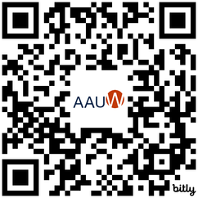
 KNOW YOUR VALUE AND GET PAID  GAIN NEGOTIATION CONFIDENCE ENSURE YOUR FINANCIAL SECURITY MANAGE YOUR FINANCES
CALLING ALL STUDENTS! THERE ARE BENEFITS AND RESOURCES AVAILABLE ON YOUR CAMPUS!



Join AAUW’s FREE virtual Salary Negotiation and Financial Literacy Trainings. Scan the QR Code above to learn more and register today!
Local Branch:
American Association of University Women WWW.AAUW.ORG

