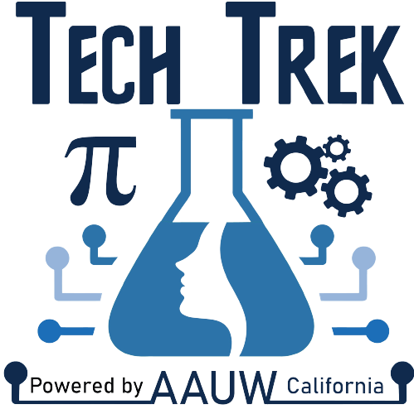

Enter today’s date
Dear Principal’s Name,
Tech Trek, an exciting week-long summer camp for current seventh-grade girls focused on science, technology, engineering, and mathematics (STEM) exploration, is returning in 2026 with residential camps on eight campuses in California alongside a virtual option. Camps are tentatively scheduled for mid-June through July. Tech Trek camperships are paid for through donations from the American Association of University Women (AAUW); there may be a nominal ($50) cost to the families, plus arranging transportation to and from camp. Many branches help families navigate financial and transportation hardships.
The program is for those who identify as girls and are currently in the 7th grade. Schools may nominate one or more girls to complete an online application and attend either an in-person or virtual interview. The local AAUW branch members may select students from your school based on their interest in pursuing a STEM field, teacher recommendation, essay, and an interview. We will again be using the online software program, CampDoc, to take applications and register selected campers.
The American Association of University Women (AAUW) sponsors this successful program across the U.S., and AAUW California is organizing the camp in your area. To learn more about the Tech Trek program, check out our webpage at https://www.aauw-ca.org/tech-trek/. Tech Trek originated in California in 1998, inspiring more than 16,000 girls over the past quarter century to get excited about STEM.
During the week of the residential camp, girls reside in a college dorm and attend a daily STEM class, perform hands-on activities, participate in one or more field trips, and interact with female STEM role models. Students can get a glimpse of what college dorm life is like while participating in engaging, hands-on projects and activities. There is one adult supervisor for every 10 campers and onsite medical personnel. MMR and current COVID-19 vaccinations are required, however, families may affirmatively opt out of the COVID-19 requirement in 2026.
Those who opt for the virtual camp participate in similar classes, hands-on workshops, and virtual field trips, and are exposed to many STEM role models in the online environment, both near-peer and multi-generational, all from the comfort of their own home. Virtual campers may also participate as virtual coaches the following year after camp. Residential campers must wait three years.
The Tech Trek model requires a current-year counselor or science, math, or technology teacher who knows the student to complete a nomination before the parent receives a link to apply, followed by a selection process with the local Tech Trek committee. Successful candidates should have a strong interest in STEM courses, no behavioral issues that could impact attendance, and be mature enough to spend a week away from their family in a supervised setting or responsible enough to show up for their virtual camp sessions. We recommend that students have at least a B in their math and science classes. Students and their families must also agree to act as Tech Trek ambassadors for five years after camp.
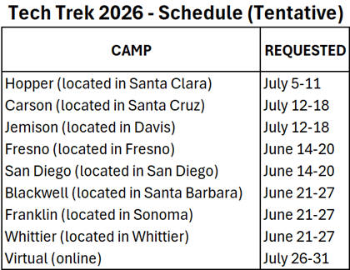
Please let me know if you have any questions or concerns. If your school wishes to participate this year, please contact me by Enter date here. My contact information is below.
Thank you for your time.
Sincerely,
Enter branch coordinator name here
Tech Trek Branch Coordinator AAUW Enter branch name Branch
Email: Enter BC email
Phone # Enter BC phone # here
Note: This opportunity is extended to all students who identify as female.

