*Today’s Date*

Dear _________,

Tech Trek, an exciting week-long STEM summer camp for current seventh grade girls, is returning in 2023 with a residential camp on several campuses in California as well as a virtual camp option. Tech Trek is a national program of The American Association of University Women (AAUW) which advances gender equity for women and girls through research, education, and advocacy. Your local AAUW branch is organizing the camp in your area. To learn more about the Tech Trek program, visit <https://www.aauw-ca.org/tech-trek/>.

The camps are tentatively scheduled for late June through July. Tech Trek campership fees are covered by the local AAUW branch through its fundraising and donation program. Some branches may request a nominal contribution from the family.

It is recommended that each school nominate up to five girls who will complete an online application and attend an interview, either virtually via Zoom or in-person at a location to be determined. Your local AAUW branch will select the final students, based on their interest in pursuing a STEM field, teacher recommendation, essay, and interview.

During the week of the residential camp, girls will live in a college dorm and attend a daily STEM class, perform hands-on activities, participate in one or more field trips, and interact with women STEM role models. Students can get a glimpse of what college dorm life is like. There is one “dorm mom” for every 10 campers, and medical personnel onsite.

Those who are enrolled in the virtual camp participate in similar classes and hands-on workshops and are exposed to a host of STEM role models in the online environment, both near-peer and multi-generational, all from the comfort of their own home. Virtual campers may also participate as virtual coaches the year following camp.

The Tech Trek camp model requires that girls be nominated by their seventh-grade science, math, or technology-related teachers in order to apply. Final selection is made by the local AAUW Tech Trek committee. Successful candidates should have a strong interest in STEM courses, no behavior issues, and be mature enough to spend a week away from their family in a supervised setting or responsible enough to show up for their virtual camp sessions. We recommend that students have at least a B in their math and science classes. Students also must be fully vaccinated, sign a code of conduct, and agree to act as Tech Trek ambassadors for five years after camp.

You will need a STEM teacher who knows the seventh-grade students to help with student nominations and the application process. Please let me know if you have any questions or concerns. If you would like to participate this year, please contact me by *Date*. My contact information is below. Thank you for your time.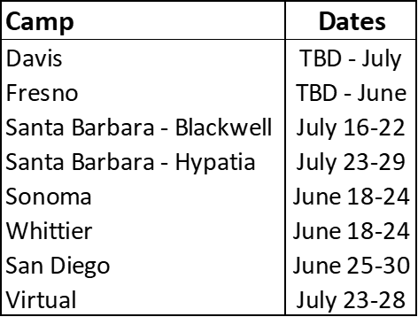

Sincerely,

|  |
| --- |
| *Tech Trek Branch Coordinator* |
| AAUWBranch: |
| Email: |
| Cellphone #: |