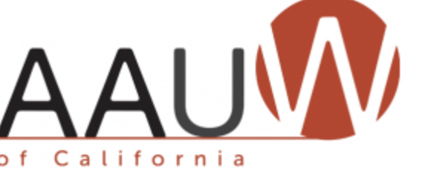
Turlock-Modesto Branch

SAVE THE DATE…… SATURDAY, FEBRUARY 26, 2022 @ 11:30 AM

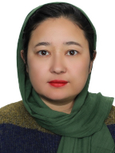
MEET OUR AAUW FELLOW FAHEEM EISSAR WHO WILL SPEAK TO US VIA ZOOM

We are very fortunate to have Faheem Eissar as our speaker this month. Faheem is a student at the University of San Francisco and is part of the program called IDEC (International Development Economics). This is a two-year program, and she is midway through her first year. She is being trained on how to tackle the problem of development in post conflict economies. Her main focus is on how war trauma can affect men and women differently and what plans and programs best work for their reintegration into a healthy post-conflict economy after the war is over. She hopes to be part of the solution for the future of Afghanistan.

If you plan to attend, please RSVP to Linda @ soleslrs@gmail.com and we will send you the Zoom link and agenda for this meeting.

Thank you in advance for joining us to listen to our 2022 Fellow speaker. Also, thank you to our AAUW member for Bjorg Johannsdottir for her assistance with Zoom.

Linda Romero Soles
AAUW VP Funds

