

Financial Literacy

Money Trek Project

Module 1: Work book

Introduction to Money Management

Presented by: Bakula Maniar, Financial Literacy Director &

AAUW-CA Financial Literacy Committees - 2011-2012 & 2012-2013

Module 1: Introduction to Money Management

Discussion

- What are the major reasons that financial literacy is so important?
  - And, why is it so important to women?

- What impact does personal finance have on women’s lives?

What are your goals?
  - Short, medium, long term?

Do you have a plan for reaching these goals?

- Do you have experience with planning?
What worked? What fell short?

Activity 1: Tracking spending

The first step in managing your money is making a budget. And the first step in making a budget is to track your spending. How do people track spending? Many simply keep all their receipts somewhere (wallet, desk, basket) until they are ready to enter the amounts into a Spending Tracker. Others track-as-they-spend by directly entering expenses into a paper-based Spending Tracker (or a phone or a tablet or laptop) that they carry with them.

The important thing to remember is to track everything, whether you paid with cash, check, credit card or debit card. And track it for at least a month. The more months the better…

Daily Spending Tracker #1 lets you enter expenses as they occur, without the need to categorize them as you go.

Daily Spending Tracker #1
Day | Expense | Paid with | Amount
Monday | Super Cuts haircut | Check #105 | $19.75
 | Rent | Check #106 | $1200.00
 | Spring Tuition | Check #107 | $3500.00
Tuesday
Wednesday | Lunch with friends | Cash | $12.00
 | Movie & Snacks | Cash | $13.00
Thursday
Friday | Weekly grocery shopping | Debit card | $80.00
Saturday | Dry Cleaning | Cash | $5.95
Sunday | Movie & snacks | Cash | $13.00
 |  | Weekly Total | $4843.70

Spending Tracker #2 lets you categorize expenses as you go.

Daily Spending Tracker #2
Expense | Mon | Tue | Wed | Thu | Fri | Sat | Sun |  | Total
Grooming/  haircut | $19.75 |  |  |  |  |  |  |  | $19.75
Food/  Restaurant |  |  | $12.00 |  |  |  |  |  | $12.00
Housing/  Rent | $1200.0 |  |  |  |  |  |  |  | $1200.0
Education/  Spring Tuition | $3500. |  |  |  |  |  |  |  | $3500.
Food/  Groceries |  |  |  |  | $80. |  |  |  | $80.00
Laundry/  Cleaning |  |  |  |  |  | $5.95 |  |  | $5.95
Entertainment |  |  | $13.00 |  |  | $13.00 |  |  | #26.00
More…..

Brainstorm:

Can you think of other ways (hint: think online) that could help to track your spending, if the receipt is lost or if you forgot to track it?

Daily Spending Tracker Workshop

Separate into 3 teams, according to which type of spending tracker you’d like to work on: for high school students, for college students or for working adults. Each team should think of typical expenses for its group, and enter the expenses into the trackers below. If you don’t know the amount of an expense, enter it anyway, and we can discuss it/research it later.

After 5 minutes, we’ll compare results.

Which of the trackers did you prefer and why?

Daily Spending Tracker #1
Day | Expense | Paid with | Amount
 |  | Weekly Total

Daily Spending Tracker #2
Expense | Mon | Tue | Wed | Thu | Fri | Sat | Sun |  | Total

When you are ready to track your actual spending, you’ll be able to find “empty” trackers (which require Microsoft Excel) on the AAUW CA website which you can either print or download to your computer. Or, you might decide to go strictly mobile, and download an expense tracker application for your phone or tablet from the Android Marketplace or the Apple App Store.

Discussion

What are some typical expenses that occur regularly, but not every week? Think about utility bills, car insurance, and, and . . . .

What are some typical expenses that occur less frequently, and may happen as complete surprises? Think about a car repair, a job move, and, and …

In the next Activity, we’ll learn how to plan for these expenses, which can be major.

Activity 2: Make a monthly income and expense worksheet (budget)

Sources and amounts of income
Regroup into your teams (high school students, college students, young working adults) and list potential sources of income and how much could be expected from each source. No need to reveal personal information! This is about what each of the categories could theoretically expect as income.

Sources of Income

High School Student |  | College Student |  | Working Adult
Allowance |  | Allowance |  | Full time job
Part-time job |  | Part-time job |  | Part-time job
 |  | Financial Aid
Others |  | Others |  | Others

Reality Check—Salaried Employee, Working Full Time

Just in case it did not sink in during the lecture, let’s revisit a sample pay stub.
http://www.surepayroll.com/calculator/calc_paycheck_netpay.asp

Assume a single California worker, with an annual salary of $60,000. Monthly gross pay is $60,000/12 = $5,000.

Using the payroll calculator, and assuming 10% 401K contribution and $250/month health insurance, monthly net pay is $3,076.

Generally speaking (and there are always exceptions and special cases) in the income bracket above, if you are single, living in California, you can expect to take home (net) about 60% of your gross pay (the figure in your offer letter).

Reality Check—Hourly Employee, Working Part Time

http://www.surepayroll.com/calculator/calc_paycheck_hourly.asp

Assume base pay of $12/hour for 10 hours and overtime pay $18/hour for 5 hours.

Note: For a single California employee, very little Federal tax and no state tax were withheld. Plan to set money aside for federal and state taxes in your Budget (Activity 2) and Monthly Payment Schedule (Activity 3) or there could be a nasty surprise at tax time in April! This is especially true if you are working more than one part-time hourly job.

Setting up and maintaining a Budget

Enter the amounts from Sources of Income above and from the Spending Tracker in Activity 1 into the Budget below. How did you do? Is the bottom line (Difference) positive or negative?

Income |  | Budget | Actual | Difference
Job #1
Job #2
Other
Total Monthly Income
Expenses | Budget |  | Actual | Difference
Fixed Regular Expenses
Saving
Giving
Fixed Irregular Expenses
Total Monthly Expenses
Difference

You’ll notice that we put saving into the budget. This is a crucial line item. You’ll need to save for periodic big-ticket expenses, like car insurance. You’ll also need to save for a contingency fund (more in future modules). Also, if you find you finished a week or month with a little extra, it’s good to set it aside. Who knows, you might want to go to some extra movies!

We also put Giving into the budget. At some times of life, giving cash is possible. At other times of life, it’s not. But, it’s always good to think about giving back, possibly by volunteering vs. cash.

You can find various budget guidelines on the Internet. They will all stress that they are presenting adjustable guidelines. This is one classic allocation from BALANCE Financial Fitness Program:

- Housing: no more than 35% of net income Savings: at least 10% throughout your working life

- Transportation: no more than 15%

- Debt: no more than 15%

- Other: no more than 25%

What would this work out to for our 25 year old college graduate, making $60,000/year with net monthly income $3076?

Expense category | Allocation | Budgeted Amount
Savings | 10% | 307
Housing | 35% | 1076
- Mortgage/Rent
- Utilities
- Insurance
- Repairs
- Taxes
Transportation | 15% | 461
- Car payments
- Insurance
- Gas
- Repairs
- Parking/tolls
- Train/bus fees
Debt | 15% | 461
- Student loans
- Credit card interest
- Personal loans
Other | 25% | 769
- Food
- Clothing
- Entertainment
- Vacations
- Childcare
- Medical
- Giving/charity

Other advisors offer the same or different allocations.
- Glinda Bridgforth’s allocations, as explained on TV on Ophrah’s Debt Diet agree with the above.

- Dave Ramsey’s allocations in his Gazelle Budget™ Lite are somewhat different.

Activity 3: Create a monthly payment schedule

Now that you know what your typical weekly, monthly, periodic and annual expenses are, you can create a monthly payment schedule, and expand it for all the months of the year to include things like car insurance payments or tuition or property tax, which do not need to be paid every month, but do occur regularly.

Here’s an example of a calendar-based Monthly Payment Schedule. Some people might keep a paper-based calendar, just for entering payments. Some may prefer a desktop/laptop Excel spreadsheet. Some might prefer a mobile computing application. All are good tools. Use the one that works best for you.

Calendar-based Monthly Payment Schedule Example

Month________________________________
Sunday | Monday | Tuesday | Wed. | Thursday | Friday | Saturday
1 | 2  $200 paycheck  $25 savings  $150 car  $25 personal  $30 insurance | 3  $166 transportation | 4 | 5  $25 interest (income) | 6  $30 cell phone | 7
8 | 9 | 10 | 11 | 12 | 13 | 14
15 | 16  $200 paycheck  $40 phone bill | 17 | 18 | 19 | 20  $10 credit card/ loan | 21
22 | 23 | 24 | 25 | 26 | 27 | 28  $40 entertainment
29 | 30

Here’s an example of a pay-period-based Monthly Payment Schedule. Some people might keep this information in a notebook, one page per month, first half of the month to the left, last half of the month to the right.

Pay-period Based Monthly Payment Schedule Example

First pay period |  |  | Second pay period
Income |  | Paid √ | Income |  | Paid √
Take home pay | $200 |  | Take home pay | $200
 |  |  | Interest | $25
Total | $200 |  | Total | $225
Expenses | Amount | Paid √ | Expenses | Amount | Paid √
Savings | $25 |  | Credit card | $10
Car | $150 |  | Entertainment | $40
Personal | $25
Transportation | $166
Cell phone | $30
Total | $396 |  | Total | $50
Difference | -$196 |  | Difference | $175

Did you notice you are short in First pay period by $ -196.00 and over by $175.00 but overall at the end of the month you are still short by -$21.00.

What are the steps you will take to avoid this situation?

Other options

Some may prefer a desktop/laptop Excel spreadsheet. Some might prefer a mobile computing application. Again, all are good tools. Use the one that works the best for you.

Mint.com is free and available for desktops/laptops, iPad, iPhone and Android
Phones & tablets. 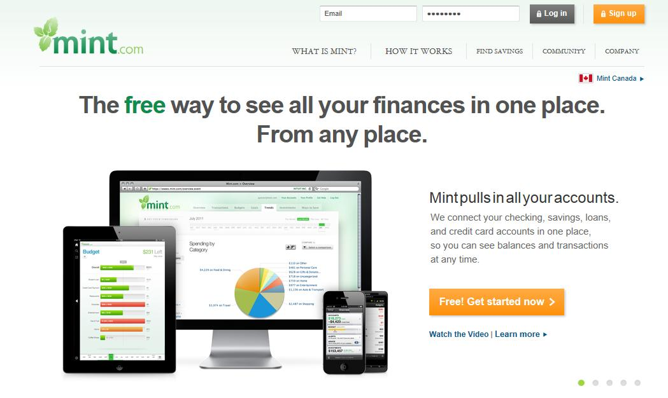

Activity 3: Monthly Payment Schedule Workshop

Enter your expenses from Activity 1 into the two Monthly Payment Schedules below. Which did you prefer?

Month________________________________
Sunday | Monday | Tuesday | Wed. | Thursday | Friday | Saturday
1 | 2 | 3 | 4 | 5 | 6 | 7
8 | 9 | 10 | 11 | 12 | 13 | 14
15 | 16 | 17 | 18 | 19 | 20 | 21
22 | 23 | 24 | 25 | 26 | 27 | 28
29 | 30 | 31

First pay period |  |  | Second pay period
Income | Amount | Paid √ | Income | Amount | Paid √
Expenses | Amount | Paid √ | Expenses | Amount | Paid √
Total |  |  | Total
Difference |  |  | Difference

