
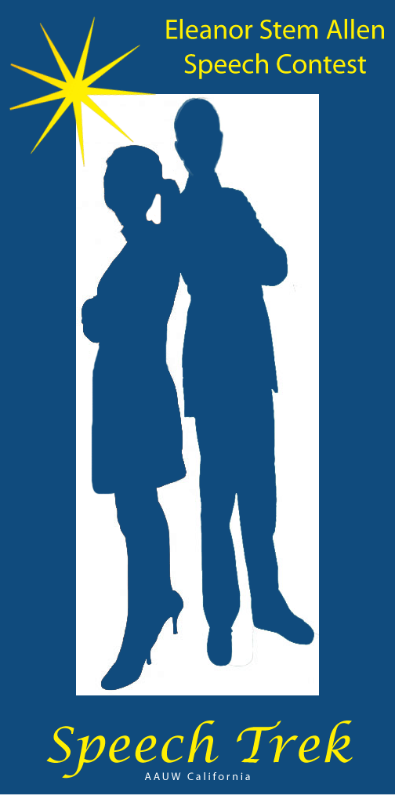
2019-2020
Speech Trek
Student Information and Forms

Contact:
Marlene Cain
AAUW CA Speech Trek Coordinator
P.O. Box 6634
Big Bear Lake, CA 92315
marcain@earthlink.net
909.866.2819

SPEECH TREK CONTEST TOPIC FOR 2019-2020:

ARE MEN AND WOMEN TRULY EQUAL TODAY, OR ARE THE SUFFRAGISTS OF 1920 STILL SUFFERING IN 2020?
“We hold these truths to be self-evident: that all men and women are created equal; that they are endowed by their Creator with certain inalienable rights; that among these are life, liberty and the pursuit of happiness…” The Declaration of Sentiments and Resolutions, Seneca Falls Conference, 1848.
These words, written 171 years ago, proclaimed equality between men and women.
Abigail Adams urged her husband to “remember the ladies” when drafting our country’s founding documents: “I desire you would remember the ladies and be more generous and favorable to them than your ancestors. Do not put such unlimited power into the hands of the husbands. Remember, all men would be tyrants if they could. If particular care and attention is not paid to the ladies, we are determined to foment a rebellion, and will not hold ourselves bound by any laws in which we have no voice or representation.”
Has society “remembered the ladies”?
1906 article: “A suffragette is a woman who ought to have more sense.”
2017 articles:
- “Female patients: it’s not all in your head”
- “Boys will be boys”
- “‘Women’s garage’ challenges Iraq society”
- “Sexism and Silicon Valley”
- “Out too late? Indian women jeer at the idea”
- “Overshadowed, two women made difference”
- “In tech, sexism is in the water”
- “Nigeria’s other abducted—and forgotten—girls”

Women have been marching toward equality for over a century, starting with the Women’s March of 1913 and continuing to the Women’s Marches at present.
Are men and women truly equal today? Or are the Suffragists of 1920 still suffering in 2020?

CONTEST INFORMATION

Eligibility: Speech Trek is open to all actively attending high school students in California.
Deadlines: Interested students must submit a "Student Application and Parent/Guardian Permission" notice to their local AAUW CA Branch (please see Page 4).
Time Limits: Students are to prepare an original 5:00-6:00 minute speech, with a 30-second grace period on either side. Speaking under 4:30 or over 6:30 will result in disqualification.
Presentation: These presentations are to be original speeches. Appropriate use of one 4" x 6" note card is an option--prompting is not allowed.
Judging: During the State Semi-Final and Final competition, judges shall use the official ballot and score each speaker in two areas: Content (includes Introduction, Organization and Conclusion), 0-50 points; and Delivery, 0-50 points. Branches may opt to use their own Judge's ballot at the local level. Students are advised to request a copy of their Branch’s Judge’s ballot.
Prizes: Each local Branch of AAUW CA will determine the level of award for their contestants.
Branch Winner: Each participating Branch will post the video of their winning speech online by March 1, 2020. The State Speech Trek judges will identify five finalists, two of whom will be named as Honorable Mention. The judges will award the 4th place finalist with $250 and the 5th place finalist with $150. The State Speech Trek judges will invite the top three finalists to compete for cash prizes at the AAUW CA State Convention/Annual Meeting on Saturday, April 18, 2020, at the Westin San Francisco Hotel.
State Finalists: First place winner at the State contest will receive $1500; Second place winner at the State contest will receive $1000; and Third place winner at the State contest will receive $500. Travel expenses, lodging, and meals for each finalist and her/his chaperone will be reimbursed by Speech Trek. Those expenses should not exceed approved budget.
Your School Contact is: _____________________________________________________________________________
Phone: ______________________________________ Email_______________________________________________
Your AAUW Branch Contact is:____________________ ________________________________________________ Phone: ______________________________________Email_______________________________________________
Your Speech Contest Coach is: ____________________________________________________________________ Phone: ______________________________________Email_______________________________________________

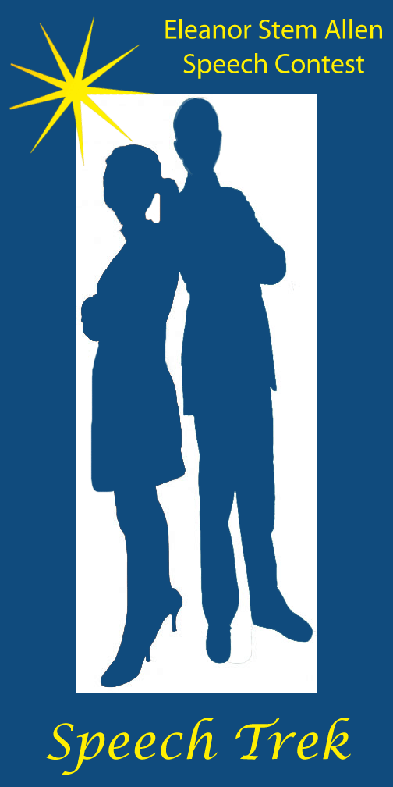
STUDENT APPLICATION AND PARENT/GUARDIAN PERMISSION

Student Name: _________________________________________________________________________
Address:________________________________________________________________________________
Email: _______________________________ Landline: ____________________Cellphone: _____________________
High School Attending: ____________________________________________________________________________
School Advisor/Counselor: _______________________________________________________________________
My signature below certifies that I wish to participate in the AAUW California Speech Contest and that I have received and read the following forms:
Student Instructions, Judge's Instructions & Ballot
Student Signature: __________________________________________________________ Date: __________________
Parent/Guardian Information and Permission:
Name: _________________________________________________________________________________________________
Address (if different):________________________________________________________________________________
Email: _______________________________ Landline: ____________________Cellphone: _____________________
My signature below certifies that I have read the rules for the speech contest and wish for my child to participate in the speech contest. In addition, I understand that my child's name may be publicized locally as a contest participant, and that the speech will be recorded for higher-level competition and selection of finalists.
If my child is selected as the 1st place branch winner or one of three state finalists, I understand that the video of my child's competition speech may be posted online (see videos of previous speakers at: aauw-ca.org>Mission Based Programs>Speech Trek) or used to promote the contest in subsequent years. I understand I will need to sign an AFFIDAVIT OF ELIGIBILITY AND LIABILITY RELEASE, prior to my child’s participation in the competition.
Parent/Guardian Signature: __________________________________________________ Date: _______________
Please return this application to your local branch contact: ________________________________________________________________________________________________________
Email: _______________________________________ phone: _________________________________________________

AFFIDAVIT OF ELIGIBILITY AND LIABILITY RELEASE
AAUW Speech Trek Contest

The undersigned participant of the American Association of University Women (AAUW) Speech Trek Contest and the participant’s parent or guardian hereby declare that they have read and understand all of the rules and conditions for the contest and that the undersigned has met all eligibility requirements on the date her contest entry was submitted.
The undersigned and the participant’s parent or guardian represent that the speech submitted to the Contest (the “Entry”) is the participant’s own original creation, and that the participant has perpetrated no fraud or deception in entering the contest or claiming any prize.
The undersigned and the participant’s parent or guardian represent and warrant that neither she/he nor any parent or guardian is an employee of AAUW, or its related, parent, affiliated and subsidiary companies, advertising and promotion agencies, or the panel of judges, nor is she/he or her parent or guardian connected with them in any way.
The undersigned and the participant’s parent or guardian irrevocably grant to AAUW, its successors and assigns and all other persons deriving rights from them, all rights, title and interest in the undersigned's Entry in perpetuity, to print, publish, broadcast, use or modify in any manner in any media whatsoever my Entry as submitted for the Contest to the fullest extent permitted by applicable law.
In addition, the undersigned and the participant’s parent or guardian grant to AAUW, its successors and assigns and all other persons deriving rights from them, the right to use the participant’s name, likeness and/or voice and biographical information, and city of residence for promotional purposes in any medium without compensation to the fullest extent permitted by applicable law.
The undersigned and the participant’s parent or guardian hereby waive the opportunity and any right to inspect or approve any such promotion, printing, broadcast use or publication, and further release AAUW, its successors and assigns from all liability in connection with any such promotion, printing, broadcast, use or publication.
The undersigned and the participant’s parent or guardian hereby release and hold harmless AAUW and its officers, directors, employees, and agents from any and all losses, claims or damages that may result, directly or indirectly, from participation in the contest or use of the prize award. The undersigned understands that any and all local, state or federal tax liability for the award will be the responsibility of the undersigned and the participant’s parent or guardian.
The undersigned and the participant’s parent or guardian further acknowledge and agree that the contest prize is non-transferable, and that no substitution of prizes will be allowed, except by the AAUW due to the unavailability of prizes at the time of the award.

The undersigned and the participant’s parent or guardian understand that AAUW is proceeding with the award of my prize in the Contest in express reliance on this release and the undersigned and the participant’s parent or guardian represent and agree that they are free to grant the rights set forth in this release.
The undersigned contest participant and the participant’s parent or guardian hereby attest that they have read and understand all the foregoing provisions of this affidavit and agree to be bound by the same.

Signature of contest participant Date

Type or print name of participant
Contest Participant’s Current Address,
Telephone Number and Social Security Number

_________________________________________________
__________________________________________________
__________________________________________________
__________________________________________________

__________________________________________________
Signature of parent/guardian (if contest participant is under 18 years of age)

Print name of parent or guardian

Dated:_____________________________________________

