

Financial Literacy

Money Trek Project

Module 2: Work book

Introduction to Money Management

Presented by: Bakula Maniar, Financial Literacy Director &

AAUW-CA Financial Literacy Committees - 2011-2012 & 2012-2013

Module 2: Banks & Checking Accounts

Activity 1: Which Bank Should I Use?

For students, another thing to check is what special student services a particular bank or credit union offers. One good way to research their student services is to go to the bank’s public home page and search on student.

While we are certainly not endorsing one bank or credit union over another, here are three with special services for students:

- Bank of America http://www.bankofamerica.com/studentbanking/index.cfm
  - Offers special incentives for students, such as e Banking with no minimum balance requirements.
  - Offers online personal financial education
    - Student Financial Handbook http://www.bankofamerica.com/studentbanking/pdf/student_handbook.pdf which covers budgeting, checking & savings, fees, etc. There’s a great quiz at the end.
    - Ultimate Money Skills
http://studentmoneyskills.bankofamerica.com/start/
online training for students covering topics like Identity Theft and many of the topics in Money Trek Project.

- JP Morgan Chase https://www.chase.com/online/services/studentcenter.htm
  - Offers special incentives for students, such as a free debit card
  - Offers some video-based online personal financial education, plus more information on Face book

- StarOne Credit Union http://www.starone.org/home/accounts/student
  - Offers special student loans, checking accounts and VISA cards
  - Offers many financial tools & calculators for everyone http://www.starone.org/home/tools/overview

Activity 2: Writing a Check & Using a Check Register

Exercise: Sample check

Fill in the blanks on this check to write check # 105 to Super Cuts on 02/16/12 for $19.75

- Enter the date

- Enter Super Cuts in Pay to the Order Of

- Enter the amount in digits in the $ box

- Spell-out Nineteen dollars and 75/100 in front of Dollars

- Optionally add a memo (haircut)

- Sign the check with your name as it appears on the account

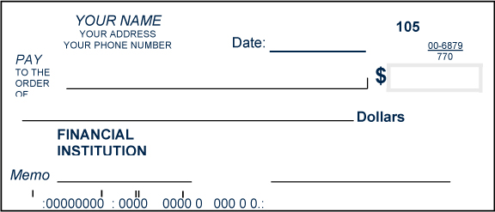

Sample Check Register

- Number or code: Enter check number or your own code for ATM withdrawal, debit card purchase, etc

- Date: Enter the date when you write the check

- Transaction Description: For a check, same as Pay to the Order of on the check. Otherwise, a note to yourself, e.g. Grocery Store

- Payment Amount/Deposit Amount: If the money is going out or paid, enter it under Payment Account. If the money is coming in or deposited, enter it under Deposit Amount

- Balance: The new amount in your account, after the payment or deposit is added or subtracted.

Exercise: Sample Check Register

Here’s what check 105 would look like in the check register. Enter a few more in the register below for practice. Compute the running balance.
- Check 106 for $1200 rent on 03/01
- Check 107 for $3500 for spring tuition on 03/01
- Debit card transaction for $80 for groceries on 03/01

Number or Code | Date | Transaction Description | Payment Amount | Deposit Amount | Balance
 |  | Opening deposit |  | 200.00 | 200.00
105 | 02/26 | Super Cuts | 19.75
 |  | Deposit |  | xxxx.xx

Brainstorm

- Why would anyone keep a paper register now, when you can do everything online?

- How big does the deposit need to be so that checks 106 and 107 do not bounce?

- What happens when you bounce a check?

- What can you do to avoid bouncing checks?

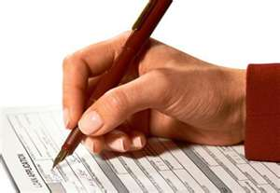

Activity 3: Balancing Checkbook

Here is a checking account statement.

We’re going to use it and the Checkbook Balancing Form below to reconcile the account.

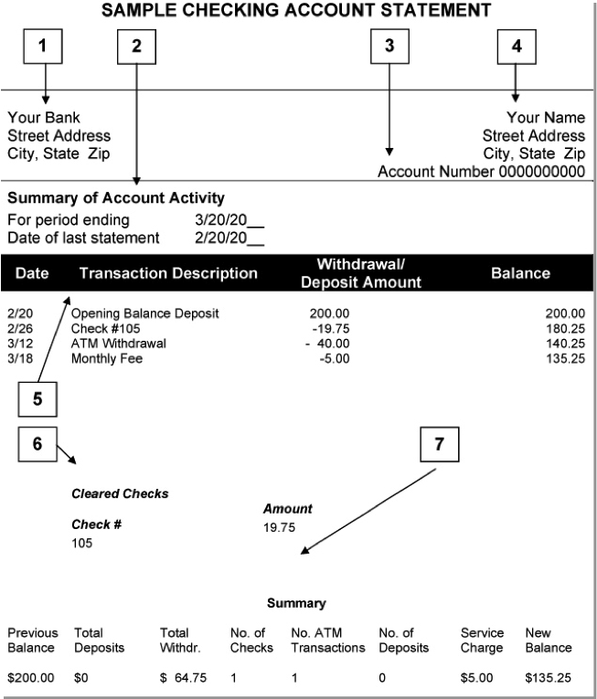

Checkbook Balancing Form

- Go back to your check register in Activity 2. Look for withdrawals (checks, ATM transactions, debit card transactions) that do appear in your register but do not appear on your statement. Enter the Date, Number/Code and Amount of these checks under Outstanding Withdrawals. Total these checks.
- Enter the Statement Balance from your Checking Account Statement.
- Copy the Total outstanding withdrawals (left column) to Subtract Outstanding Withdrawals (right column).
- In the right columns, compute Total by subtracting Outstanding Withdrawals from Statement Balance (right column).
- Go back to your check register. Look for deposits that do appear in your register but do not appear on your statement. Enter these deposits in Add Outstanding Deposits.
- Compute the new Balance by adding the Outstanding Deposits to Total.
- The Statement Balance (from the bank) and the new Balance (in your register) should match, after you enter any checking account interest earned and fees in your checkbook register.

Outstanding Withdrawals
Date | Number/Code | Amount
 |  |  |  | Statement Balance
 |  |  |  | Subtract Outstanding Withdrawals | -
 |  |  |  | Total
 |  |  |  | Add Outstanding Deposits | +
 |  |  |  |  | +
 |  |  |  |  | +
 |  |  |  |  | +
 | Total |  |  | Balance as per check book

Discussion

- What if the balances do not match?
  - What could have gone wrong?
  - How would you fix it?

- In the checking account statement, do you see any bounced checks?

- What do you think the bank fee is for a bounced check

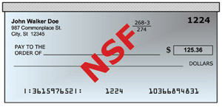

Discussion:

- Do you know what FDIC Stands for?

- Why is important to have bank with FDIC symbol?

- FDIC stands for Federal Deposit Insurance Corporation. The FDIC was created in response to the thousands of bank failures or the 1920s and 1930s. Since the FDIC was established, no one has lost money (up to the $250,000 limit) because of the failure of an FDIC-insured bank. Be sure to do business with only FDIC insured banks and credit unions.



