**Background**

Our website is hosted and maintained by Pauli Systems. We pay them a monthly maintenance fee ($100/month) to support our site. Any work done by them is paid at a *time and materials* rate. AAUW Staff and volunteers can post items to the website and send emails to distribution groups. Structural changes are done by Pauli Systems.

**Major functions of the website**

There are 3 parts to our website environment

* Our face to the world (User interface)
* Board Officer Report (BOR) database tracks branch leadership and state committee participants
* Email distribution groups from BOR database to support B2B and Briefly communications

**Why change now?**

Our hosting **technology is old** (end of life was 2014), **proprietary** and will **no longer be supported** as of December 2016. We can just fix the technology problem and leave the rest alone, or we can take this opportunity to improve our maintenance interface and user interface.

**Options** – Four options from Pauli Systems and one option from AAUW.org have been explored.

* Do the minimum – fix the underlying issue (back end) and leave everything else same. The user interface and maintenance interface remain unchanged. (Pauli Systems)
  + Keep proprietary Adobe back end (Option 1)
  + Move to an open source back end (Option 2)
* Move to a more current technology – PHP and WordPress – fix the back end and improve ability to maintain the content (Pauli Systems). WordPress industry standard and used by branches utilizing AAUW National hosting.
  + Keep the same user look and feel (Option 3)
  + Rebuild the front end to be more user friendly (Option 4) <-RECOMMENDED
* Move to AAUW National Hosting
  + Site will look like a branch site - rebuild the front end
  + Reduces hosting costs
  + Key functionality will need to be built by National
    - BOR (modified Member Services Database)
    - Email from BOR to support

**Risks**

Pauli Systems vs. AAUW National

|  |  |
| --- | --- |
| Pauli Systems | AAUW National |
| * Proven support history * http://m.whistlerblackcomb.com/m/images/app-danger-scale-full.jpgDesign support for user interface refresh * More flexibility in user interface * BOR integrated | * 1 web developer for > 500 sites * http://m.whistlerblackcomb.com/m/images/app-danger-scale-full.jpgDependent on AAUW National to clone MSD and develop email distribution capabilities * Single template option |

**Recommendation**

Pursue **option four** immediately in order to migrate before or close to the time when the underlying technology is no longer supported. Option four is recommended for the following reasons:

* Options one and two provide a basic upgrade at a minimal cost, however we will continue to be on an old technology platform and our content management ability will continue to be limited. The user interface will remain unchanged. Compatibility issues may arise and we will be at risk for paying for them on a T&M basis.
* Options three and four are similar in cost. Option four provides the added benefit of redesign of the user interface, providing a better user experience using WordPress, a tool that is used by branches maintaining their own sites. This may provide an opportunity to tap branch members to assist with maintenance. All three components will be upgraded including the back end infrastructure, user interface and content maintenance interface.
* Options one through four involve support and implementation planning and ongoing support from Pauli Systems who has provided excellent service with the existing website. Pauli Systems support has been key to continuity as the communications team members are volunteer and change over time.
* Option five appears enticing from a cost perspective, but it puts us at considerable risk relying on AAUW National to clone and upgrade the existing Member Services Database and modify it to meet our needs to track our branch leaders and email them. In the future they expect to offer additional templates but no firm date exists and the current template is limited. Additionally, only one support person exists for more than 500 websites and our needs may not be the prime interest.

The following two tables outline key components of all five options.

**Options** **Summary**

Recommendation

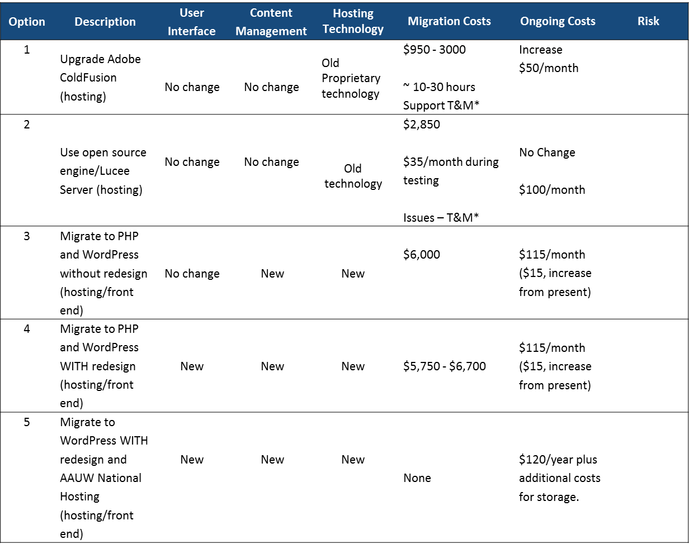

**Options** **Details**

|  |  |  |  |  |  |  |  |  |
| --- | --- | --- | --- | --- | --- | --- | --- | --- |
| **Option** | **Description** | **User Interface** | **Content Management** | **Back End** | **Pros** | **Cons** | **Migration Costs** | **Ongoing Costs** |
| Fix the back end only | | | | | | | | |
| 1 | Upgrade Adobe ColdFusion | No Change | No Change | * Updated but still old technology * Potential compatibility issues | Less expensive | * Continue on proprietary software. * No improvement in user or maintenance interface | $950 - 3000  ~ 10-30 hours Support  = time and materials | Increase $50/month |
| 2 | Use open source engine Lucee Server | No Change | No Change | * Updated but still old technology * Potential compatibility issues | Moves to more open source functionality. | * Back end upgrade only. * No improvement in user or maintenance interface | $2,850  $35/month during testing  Issues – time and materials | No Change  $100/month |
| Fix back end and improve content management process | | | | | | | | |
| 3 | Migrate to PHP and WordPress without redesign | No Change | NEW   * WordPress as CMS * CiviCRM for Directory/BOR and email communication. | Updated Technology | New content management interface | No improvement in user interface | $6,000 | $115/month ($15, increase from present) |
| Fix back end, improve content management process and redesign front end | | | | | | | | |
| 4 | Migrate to PHP and WordPress WITH redesign | NEW | NEW   * WordPress as CMS * New domain for BOR | Updated Technology | * Moves to new technology * New front end * New content management interface | 2 domains – one for website, one for BOR | $5,750 - $6,700 | $115/month ($15, increase from present) |
| 5 | Migrate to WordPress WITH redesign and AAUW National Hosting | NEW | NEW | Updated Technology | * Moves to new technology * New front end * New content management interface | Relies on National to clone Member Services database, migrate content and establish email for B2B and Briefly | None | $120/year plus additional costs for storage. |