______________

Dear ,

Tech Trek, an exciting week-long summer camp for current seventh grade girls focused on science, technology, engineering, and mathematics (STEM) is returning in 2024 with residential camps on several campuses in California alongside a virtual option. Camps are tentatively scheduled for mid-June through July. Tech Trek camperships are paid for through donations from the American Association of University Women (AAUW); there may be a nominal ($50) cost to the families, plus arranging transportation to and from camp.
The program is for those who identify as girls who are currently in the 7th grade. Schools may nominate one or more girls to complete an online application and attend either an in-person or Zoom interview. The local AAUW branch members may select students from your school, based on their interest in pursuing a STEM field, a teacher recommendation, essay, and interview. We will again be using the online software program, CampDoc, to take applications and register selected campers.
The American Association of University Women (AAUW) sponsors this successful program across the U.S., and AAUW California is organizing the camp in your area. To learn more about the Tech Trek program, check out our webpage at https://www.aauw-ca.org/tech-trek/. Tech Trek originated in California in 1998, inspiring nearly 15,000 girls over the past 26 years to get excited about STEM.
During the week of the residential camp, girls reside in a college dorm and attend a daily STEM class, perform hands-on activities, participate in one or more field trips, and interact with female STEM role models. Students can get a glimpse of what college dorm life is like while participating in engaging, hands-on projects and activities. There is one “dorm mom” for every 10 campers and onsite medical personnel. MMR and recommended Covid vaccinations are required, however families may affirmatively opt out of the Covid requirement in 2024.
Those who opt for the virtual camp participate in similar classes and hands-on workshops and are exposed to many STEM role models in the online environment, both near-peer and multi-generational, all from the comfort of their own home. Virtual campers may also participate as virtual coaches the following year after camp.
The Tech Trek camp model requires that girls must first be nominated by their seventh-grade science, math, or technology teachers in order to apply and then be selected by their local AAUW Tech Trek committee for attendance. Successful candidates should have a strong interest in STEM courses, no behavioral issues that could impact attendance, and be mature enough to spend a week away from their family in a supervised setting or responsible enough to show up for their virtual camp sessions. We recommend that students have at least a B in their math and science classes. Students and their families must also agree to act as Tech Trek ambassadors for five years after camp.
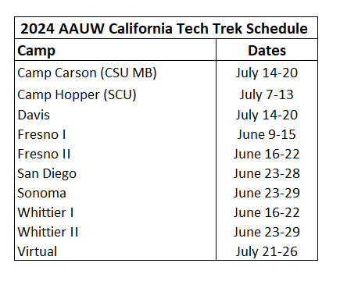
You will need a STEM teacher who knows the seventh-grade students to help with student nominations and the application process. Please let me know if you have any questions or concerns. If you would like to participate this year, please contact me by . My contact information is below. Thank you for your time.
Sincerely,

Tech Trek Branch Coordinator AAUW
Email:
Phone #
Note: This opportunity is extended to all students who identify as female.

Rev. January 2024

