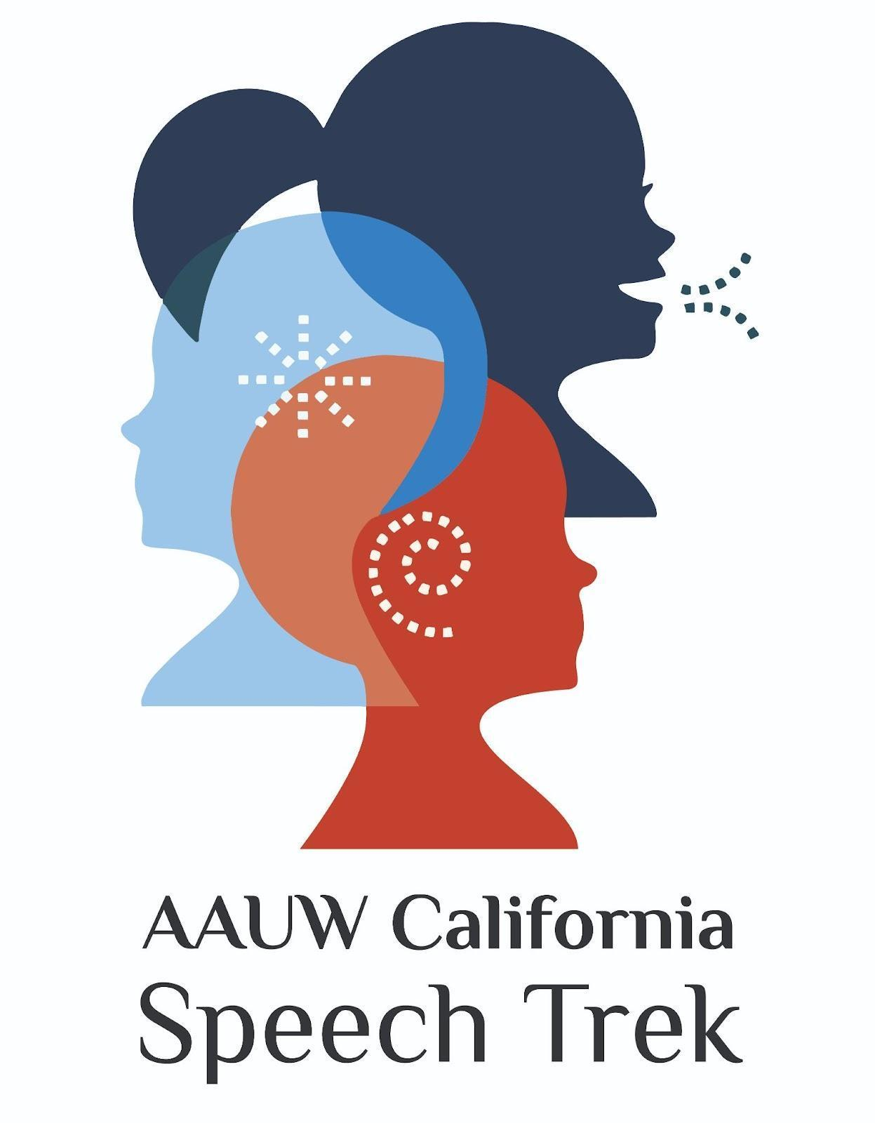
Student Toolkit
2023-2024

ATTENTION:
Speech Trek contests may take place in-person or virtually this year.
Please contact your local AAUW branch for more information.

Contact:
Lana Widman
AAUW California Speech Trek Program Director
15 Shearwater Court
Sacramento, CA 95833
speechtrek@aauw-ca.org
916-207-5160 cell

TABLE OF CONTENTS

2023-2024 SPEECH TREK SPEECH CONTEST TOPIC 3
CONTEST INFORMATION 4
STUDENT APPLICATION AND PARENT/GUARDIAN PERMISSION 5
AFFIDAVIT OF ELIGIBILITY AND LIABILITY RELEASE 6
2023-2024 - JUDGES BALLOT 8

2023-2024 SPEECH TREK SPEECH CONTEST TOPIC
Topic: How can we ensure a robust public-school curriculum that is accessible to all and teaches historically accurate information?
Background:
An educated population is essential to a nation's prosperity, according to many world leaders.
If so, then what is the best way to ensure a robust and accurate public-school education?
Imagine you could design your own high school curriculum:
- What topics would you include and why?
- Would there be topics you would exclude?
- How would you ensure the accuracy of your curriculum?
- Who would you designate as the final decision maker of your course content?
These questions arise as school curricula, textbooks, and library resources are undergoing changes across the country which will impact students of all ages and backgrounds.
Are these changes beneficial or detrimental to what you learn in school?
Throughout history, leaders around the world have credited education as the main driver of prosperity and democracy, including in the United States ¹. This finding leads us to the even bigger question :
How can we ensure a robust public-school curriculum that is accessible to all and teaches historically accurate information?

¹ “The real safeguard of democracy…is education.” Franklin D. Roosevelt
¹ “Education is the road to equality and citizenship.” Martin Luther King

CONTEST INFORMATION
Eligibility: Speech Trek is open to all actively attending high school students in California.
Deadlines: Interested students must submit a "Student Application and Parent/Guardian Permission" notice to their local AAUW California branch per the date set by that branch (please see Page 4).
Time Limits: Students are to prepare an original 5:00-6:00 minute speech, with a 30-second grace period on either side. Speaking under 4:30 or over 6:30 will result in disqualification.
Presentation: These presentations are to be original speeches. Appropriate use of one 4" x 6" note card is an option--prompting is not allowed.
Judging: During the state semifinal and final competitions, judges shall use the official ballot and score each speaker in two areas: Content (includes Introduction, Organization, and Conclusion), 0-50 points and Delivery, 0-50 points. Branches may opt to use their own judge's ballot at the local level. Students are advised to request a copy of their branch’s judge’s ballot.
Prizes: Each local branch of AAUW California will determine the level of award for their contestants.
Branch Winner: Each participating branch will post the video of their winning speech online (via YouTube) by March 15, 2024. The state Speech Trek judges will identify five finalists, two of whom will be named as Honorable Mention. The judges will award the 4th place finalist with $250 and the 5th place finalist with $150. A new panel of three judges will view the top three finalists’ videos and determine the 1st, 2nd and 3rd place winners. The top three finalists’ videos will be showcased at the virtual AAUW California Annual Event on April 27, 2024. Winners will be announced at that time.
State Finalists: First place winner at the state contest will receive $1500; second place winner at the state contest will receive $1000; and third place winner at the state contest will receive $500. If held live, travel expenses, lodging, and meals for each finalist and her/his chaperone will be reimbursed by Speech Trek. Families should contact the Speech Trek Program Director for the spending limits on reimbursable expenses.
Your School Contact is: _____________________________________________________________________________
Phone ______________________________________ Email_______________________________________________
Your AAUW Branch Contact is:____________________ ________________________________________________ Phone______________________________________Email________________________________________________
Your Speech Contest Coach, if provided, is: _____________________________________________________________________ Phone______________________________________Email________________________________________________

STUDENT APPLICATION AND PARENT/GUARDIAN PERMISSION
Student Name
Address:
Email: | Phone:
High School Attending:
School Advisor/Counselor:
My signature below certifies that I wish to participate in the AAUW California Speech Contest and that I have received and read the following forms:
∎ Student Instructions ∎ Judge’s Instructions & Ballot
Student Signature: | Date:
Parent/Guardian Information and Permission:
Name:
Address:
Email: | Phone:
My signature below certifies that I have read the rules for the speech contest and wish for my child to participate in the AAUW California Speech Trek Contest. In addition, I understand that my child's name may be publicized locally as a contest participant, and that the speech will be recorded for higher-level competition and selection of finalists.
If my child is selected as the 1st place branch winner or one of three state finalists, I understand that the video of my child's competition speech may be posted online (see videos of previous speakers at: aauw-ca.org>Programs/Project>Speech Trek) or used to promote the contest in subsequent years. I understand I will need to sign an AFFIDAVIT OF ELIGIBILITY AND LIABILITY RELEASE, prior to my child’s participation in the competition.
Parent/Guardian Signature: __________________________________________________ Date: ______________
Please return this application to your local branch contact: ____________________________________________________________________________________
Email: _______________________________________ Phone: _________________________________

AFFIDAVIT OF ELIGIBILITY AND LIABILITY RELEASE
AAUW Speech Trek Contest
The undersigned participant of the American Association of University Women (AAUW) Speech Trek Contest and the participant’s parent or guardian hereby declare that they have read and understand all of the rules and conditions for the contest and that the undersigned has met all eligibility requirements on the date their contest entry was submitted.
The undersigned and the participant’s parent or guardian represent that the speech submitted to the contest (the “Entry”) is the participant’s own original creation, and that the participant has perpetrated no fraud or deception in entering the contest or claiming any prize.
The undersigned and the participant’s parent or guardian represent and warrant that neither she/he nor any parent or guardian is an employee of AAUW, or its related, parent, affiliated and subsidiary companies, advertising and promotion agencies, or the panel of judges, nor is she/he or any parent or guardian connected with them in any way.
The undersigned and the participant’s parent or guardian irrevocably grant to AAUW, its successors and assigns and all other persons deriving rights from them, all rights, title and interest in the undersigned's Entry in perpetuity, to print, publish, broadcast, use or modify in any manner in any media whatsoever the Entry as submitted for the contest to the fullest extent permitted by applicable law.
In addition, the undersigned and the participant’s parent or guardian grant to AAUW, its successors and assigns and all other persons deriving rights from them, the right to use the participant’s name, likeness and/or voice and biographical information, and city of residence for promotional purposes in any medium without compensation, to the fullest extent permitted by applicable law.
The undersigned and the participant’s parent or guardian hereby waive the opportunity and any right to inspect or approve any such promotion, printing, broadcast use or publication, and further release AAUW, its successors and assigns from all liability in connection with any such promotion, printing, broadcast, use or publication.
The undersigned and the participant’s parent or guardian hereby release and hold harmless AAUW and its officers, directors, employees, and agents from any and all losses, claims or damages that may result, directly or indirectly, from participation in the contest or use of the prize award. The undersigned understands that any and all local, state or federal tax liability for the award will be the responsibility of the undersigned and the participant’s parent or guardian.
The undersigned and the participant’s parent or guardian further acknowledge and agree that the contest prize is non-transferable, and that no substitution of prizes will be allowed, except by the AAUW due to the unavailability of prizes at the time of the award.

The undersigned and the participant’s parent or guardian understand that AAUW is proceeding with the award of any prize in the contest in express reliance on this release and the undersigned and the participant’s parent or guardian represent and agree that they are free to grant the rights set forth in this release.
The undersigned contest participant and the participant’s parent or guardian hereby attest that they have read and understand all the foregoing provisions of this affidavit and agree to be bound by the same.

Signature of contest participant Date

Type or print name of contest participant
Participant’s current address
Telephone number

_________________________________________________
__________________________________________________
__________________________________________________
__________________________________________________

__________________________________________________
Signature of parent/guardian (if contest participant is under 18 years of age)

Print name of parent or guardian

Dated:_____________________________________________

2023-2024 - JUDGES BALLOT
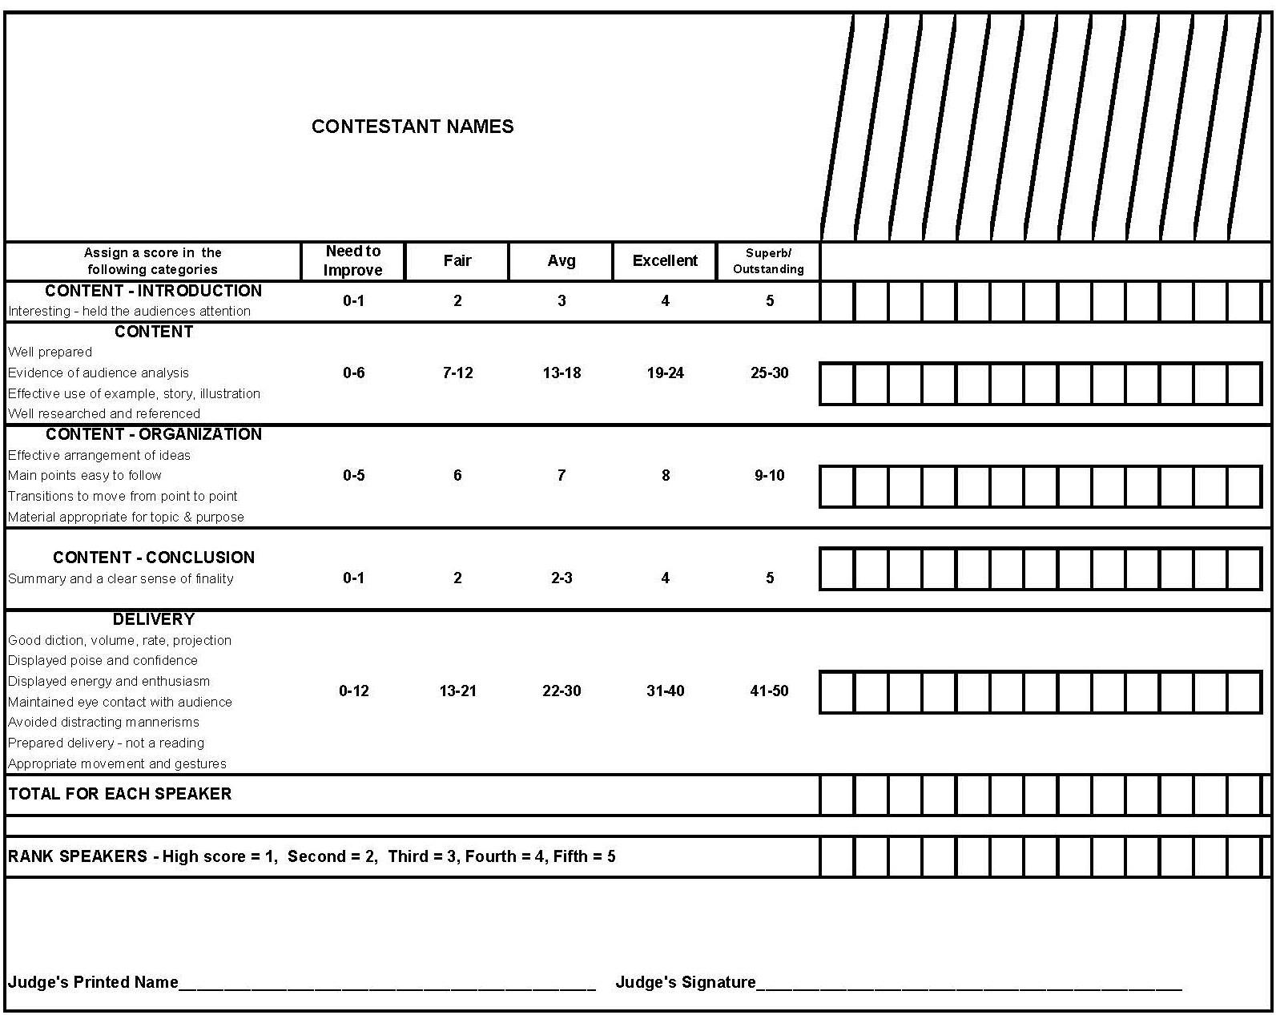
Topic: How can we ensure a robust public-school curriculum that is accessible to all and teaches historically accurate information?

