Branch Toolkit
A step-by-step guide for running a Speech Trek Contest
at your branch and state levels.

Contact:
Lana Widman
AAUW California Speech Trek Program Director
15 Shearwater Court
Sacramento, CA 95833
speechtrek@aauw-ca.org
916-207-5160 cell

TABLE OF CONTENTS

Branch-Level Speech Trek Speech Contest 3
2023-2024 Speech Trek Speech Contest Topic 5
Memorandum Of Understanding 6
Student Application And Parent/Guardian Permission 10
Branch Notice Of Contest Semi-Finalist 2023-2024 11
Branch-Level Speech Trek Speech Contest 12
Speech Trek 2023-2024 Schedule 14
Speech Trek Process 15
Sample Letter To School Administrator 16
Sample Letter To Teacher 17
Student Instructions 18
Instructions For Greeter 20
Instructions For Timer 21
Instructions To Judges 22
2023-2024 - Judges Ballot 23
Sample News Release - Before The Event 24
Sample News Release - After The Event 25
Affidavit Of Eligibility And Liability Release 26

BRANCH-LEVEL SPEECH TREK SPEECH CONTEST

Speech Trek is a speaking contest open to all California high school students, whether from public, private, home, or continuation high schools. Students who were among the top three finalists in the state contest may not compete again in any future state Speech Trek contests.
- The contest begins when your branch of AAUW California decides that they want to participate in the contest. Your board will meet and then determine the level of financial support necessary from your branch. Budget items may include prizes, printing, postage, video preparation, refreshments, or space rental for the contest. Branches vary in levels of prizes awarded to contestants--from certificates to actual cash awards. Your local branch covers all costs. Be sure to budget for the AAUW California Speech Trek Contest entry fee of $25.
- Next, identify a member to coordinate your contest and form a committee of interested members. Draw from members with interest or expertise with public speaking, writing press releases, connecting with high schools, recruiting, training, tutoring or coaching students, conducting fundraising; or just with an interest in raising awareness about the contest.
- Develop a calendar for the contest. Take time to check against competing events, such as the Lions Club Speech Contest, Rotary Speech Contest, Mock Trial, F.F.A. and other area speech contests, etc. Your calendar should include dates for:
- Notice to state Speech Trek Program Director of branch’s MOU. (Deadline is November 18, 2023.)
- Date of branch competition
- Date for submitting branch winner's online submission to the state semifinals. (Deadline is March 15, 2024.)
- Date of state competition if named to top three in the state. NOTE: State finals’ top three videos will be showcased at the AAUW California Annual Event on Saturday, April 27, 2024. This event will be virtual. Winners will be announced at this meeting.
- Create a list of your area high schools. Decide whether your contest will be limited to students within your city or county, and if it will be in-person or virtual. Create posters and recruitment brochures. Develop an email list for specific contact people to save costs of postage and printing.
- Arrange for informational meetings at your schools. Be willing to speak to student groups or classes. Your school may have a debate club or forensics program--or a Future Business Leaders chapter--or even a Mock Trial group just waiting for an opportunity to speak!
- Have the student and parent sign the participation agreement. This will protect your branch and allow it to publicize, photograph, and post the names of the participants.
- Write press releases to announce the contest.
- Notify AAUW California via the completed MOU that your branch intends to participate in Speech Trek by November 18, 2023. The online MOU asks for the branch name and mailing address as well as the president’s name and email address.
- Offer tutoring services to contestants. Tutors with experience may be available from local community college communication instructors or from local Toastmasters clubs. Working with the students helps to keep them on task with the topic and deadlines. You may decide to have a "rehearsal" prior to your contest or if participation is great, you may need to hold a semi-final round prior to your branch final contest.
- Hold your branch Speech Trek contest; video all speeches so that the winning speech can be posted to the AAUW California YouTube channel for submission to be considered at the state competition. NOTE: Only date-stamped videos taken AT the branch competition may be considered for the state competition; any taken after that date are automatically disqualified for consideration in the state competition.
- Prepare press releases of your branch winner for submission to local media.
- Submit a BRANCH NOTICE OF CONTEST SEMI-FINALIST 2023-2024 form, which includes the YouTube URL and link, and $25 fee made out to AAUW CA SPF (Special Projects Fund) with “Speech Trek” and <branch name> on the note line to Lana Widman, AAUW California Speech Trek Program Director, 15 Shearwater Court, Sacramento, CA, 95833, for the state semi-final round on or before March 15, 2024.
- Plan on attending the virtual AAUW California Annual Event to hear the top three speakers via video and see who will win the $1500 first prize. (If held in person, transportation, lodging, and meals for the finalists and one chaperone each are paid by Speech Trek.)
- Keep records for next year's contest. Share your success with our state Speech Trek Program Director at speechtrek@aauw-ca.org or call Lana Widman at (916) 207-5160.
The state Speech Trek Program Director is available to work with you to assure success with your competition. Have fun with this contest. This is an opportunity to increase awareness of AAUW in your community while having direct contact with high school students, their parents, and area educators.

2023-2024 SPEECH TREK SPEECH CONTEST TOPIC
Topic: How can we ensure a robust public-school curriculum that is accessible to all and teaches historically accurate information?
Background:
An educated population is essential to a nation's prosperity, according to many world leaders.
If so, then what is the best way to ensure a robust and accurate public-school education?
Imagine you could design your own high school curriculum:
- What topics would you include and why?
- Would there be topics you would exclude?
- How would you ensure the accuracy of your curriculum?
- Who would you designate as the final decision maker of your course content?
These questions arise as school curricula, textbooks, and library resources are undergoing changes across the country which will impact students of all ages and backgrounds.
Are these changes beneficial or detrimental to what you learn in school?
Throughout history, leaders around the world have credited education as the main driver of prosperity and democracy, including in the United States ¹. This finding leads us to the even bigger question :
How can we ensure a robust public-school curriculum that is accessible to all and teaches historically accurate information?

¹ “The real safeguard of democracy…is education.” Franklin D. Roosevelt
¹ “Education is the road to equality and citizenship.” Martin Luther King

MEMORANDUM OF UNDERSTANDING
The Memorandum of Understanding (MOU) document is available to complete online HERE.
Hard copies are no longer required to be mailed in. The sample below is provided for reference.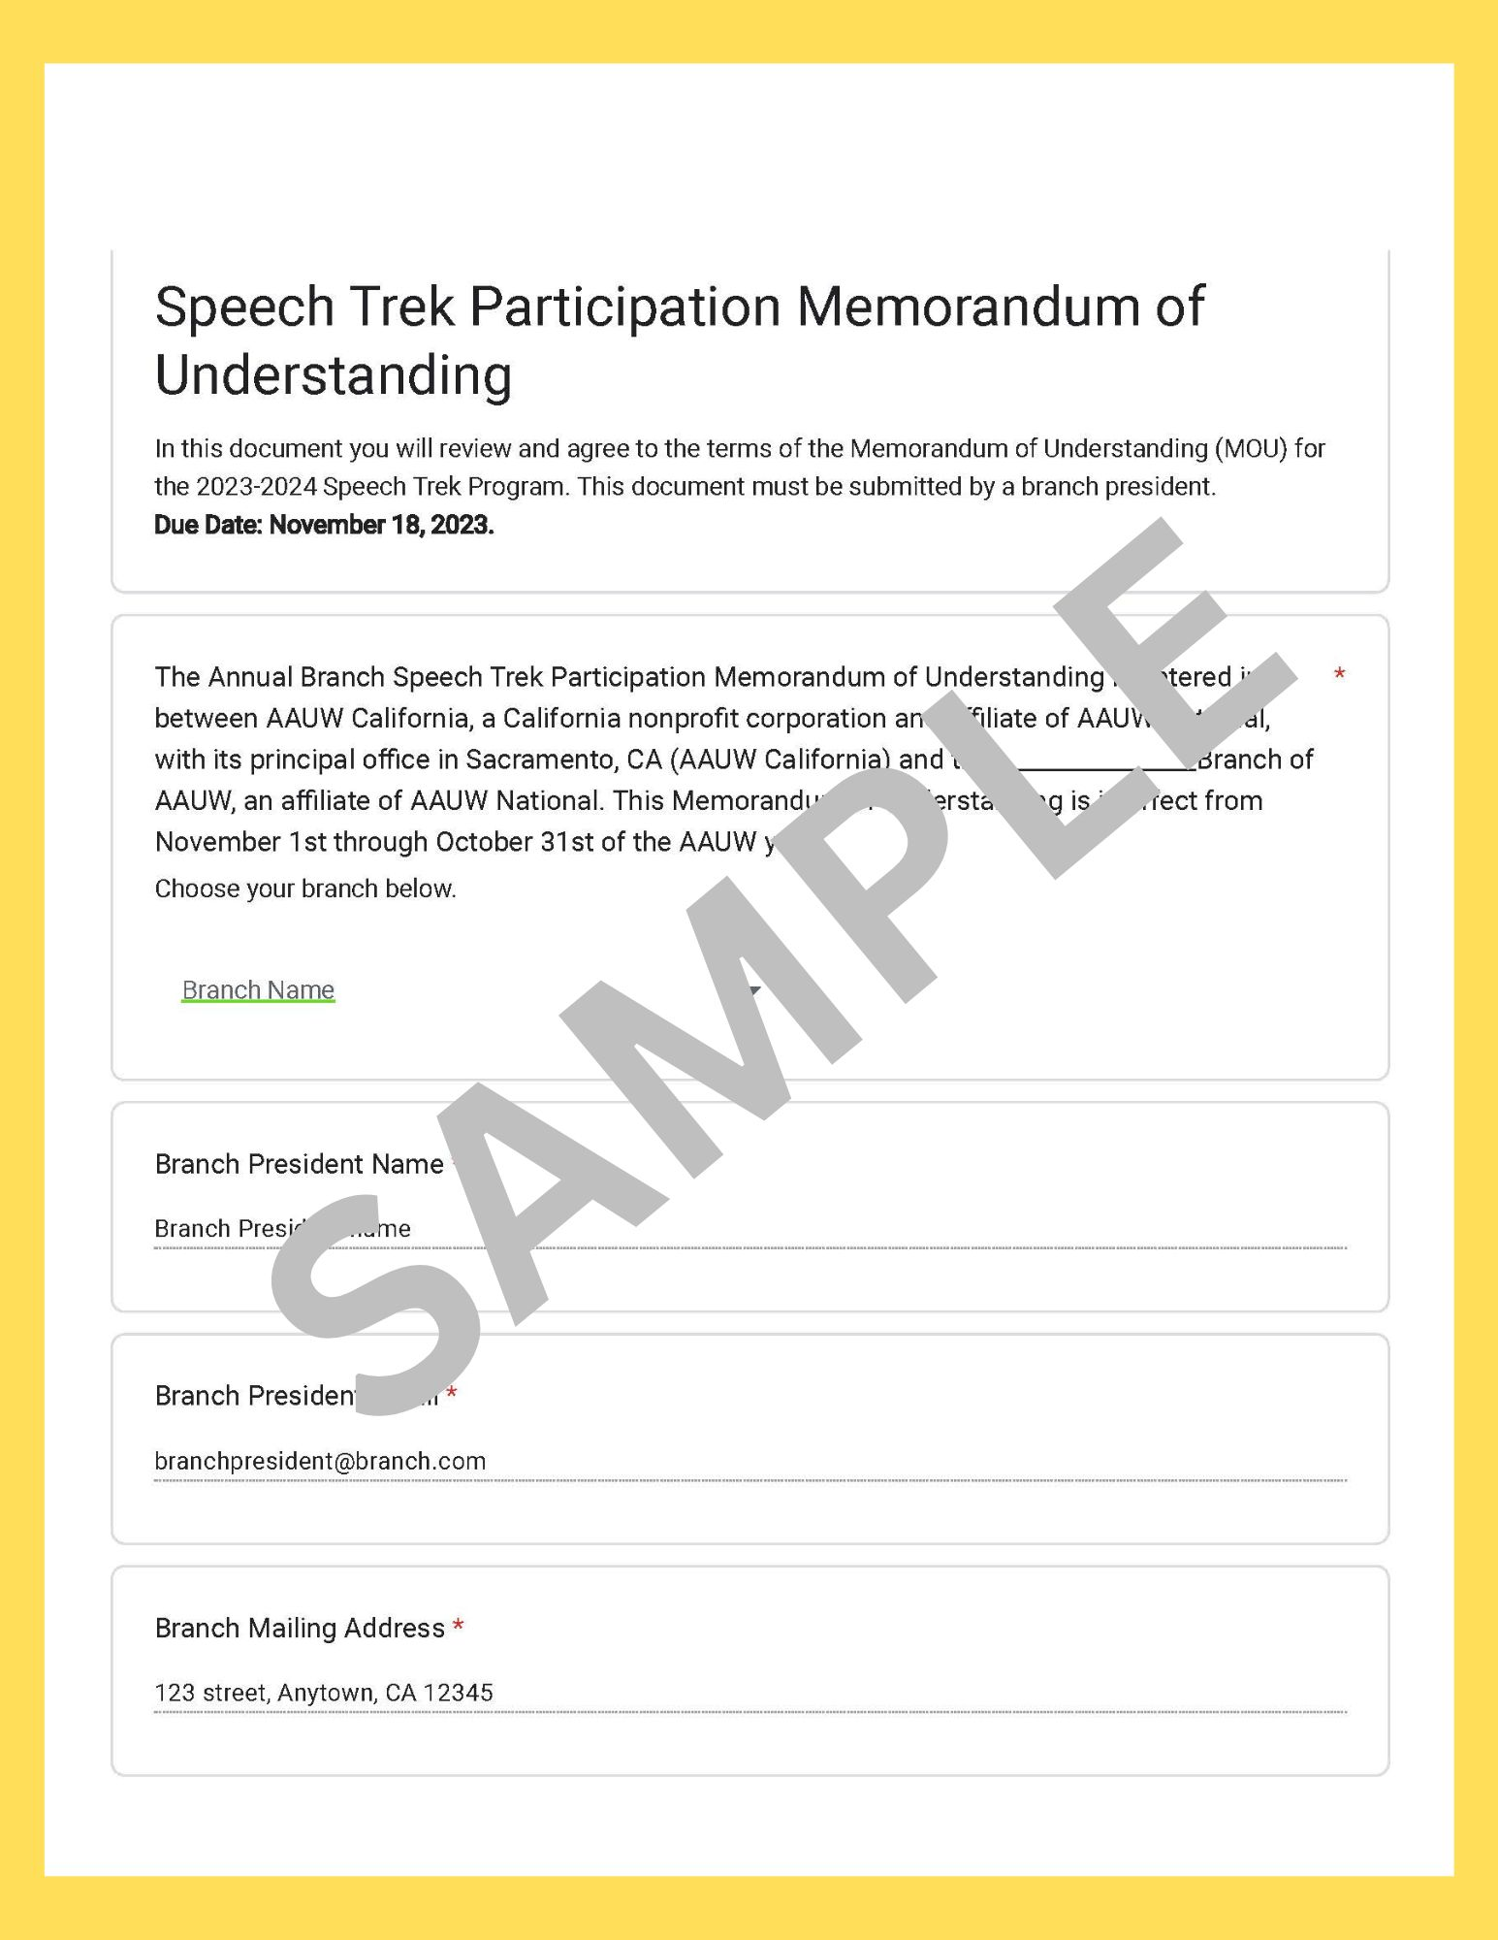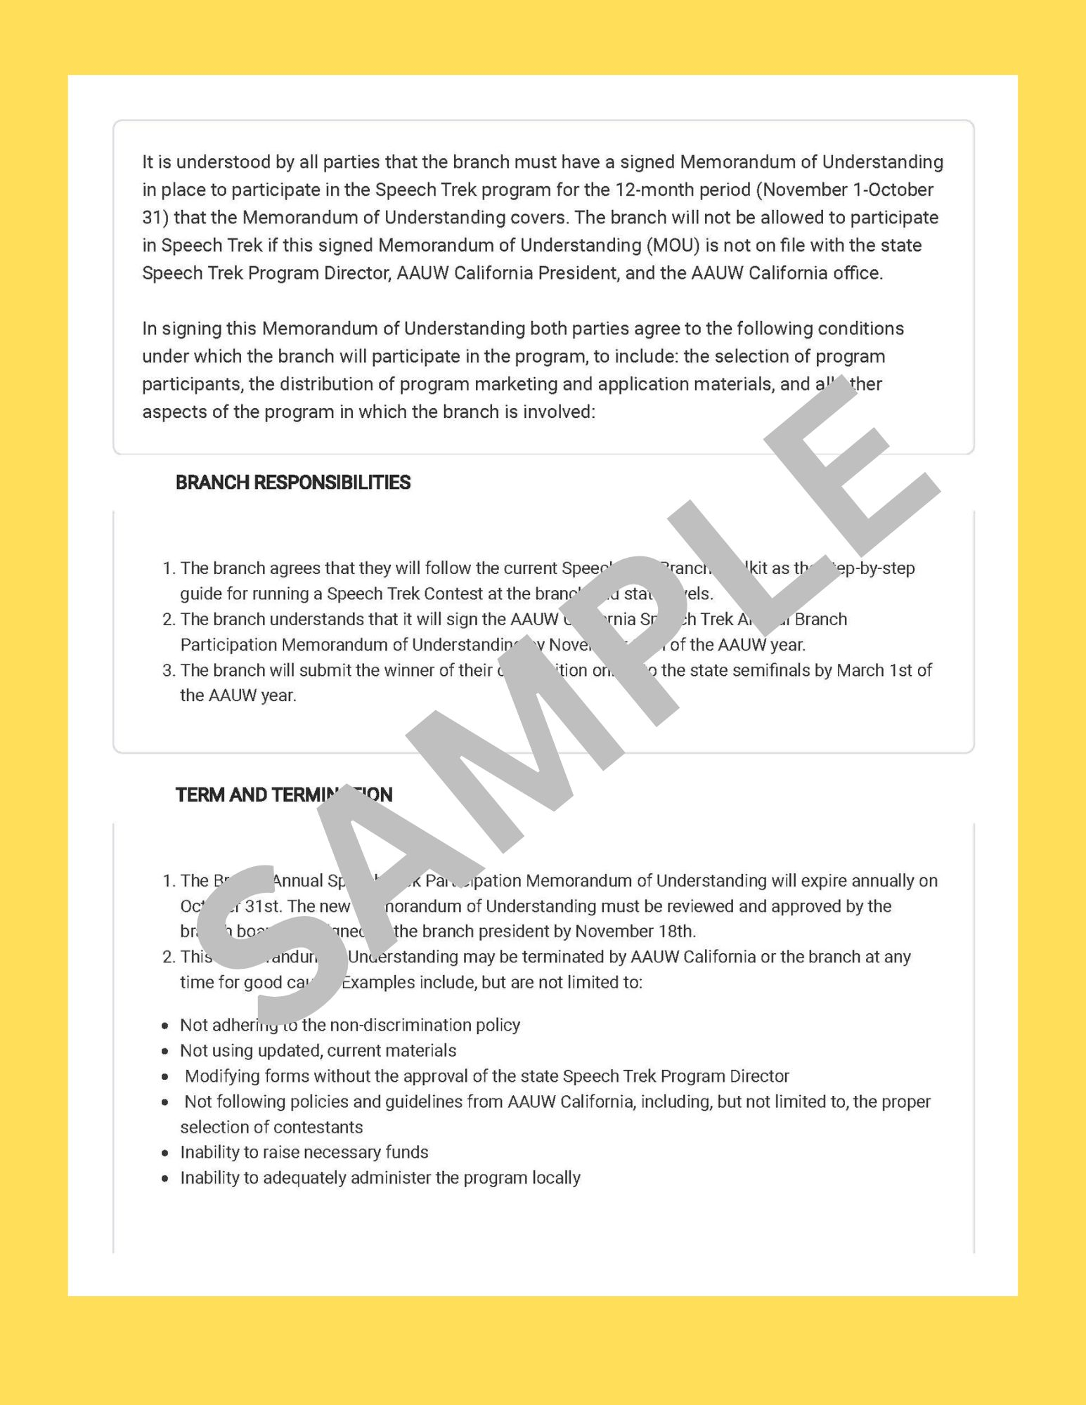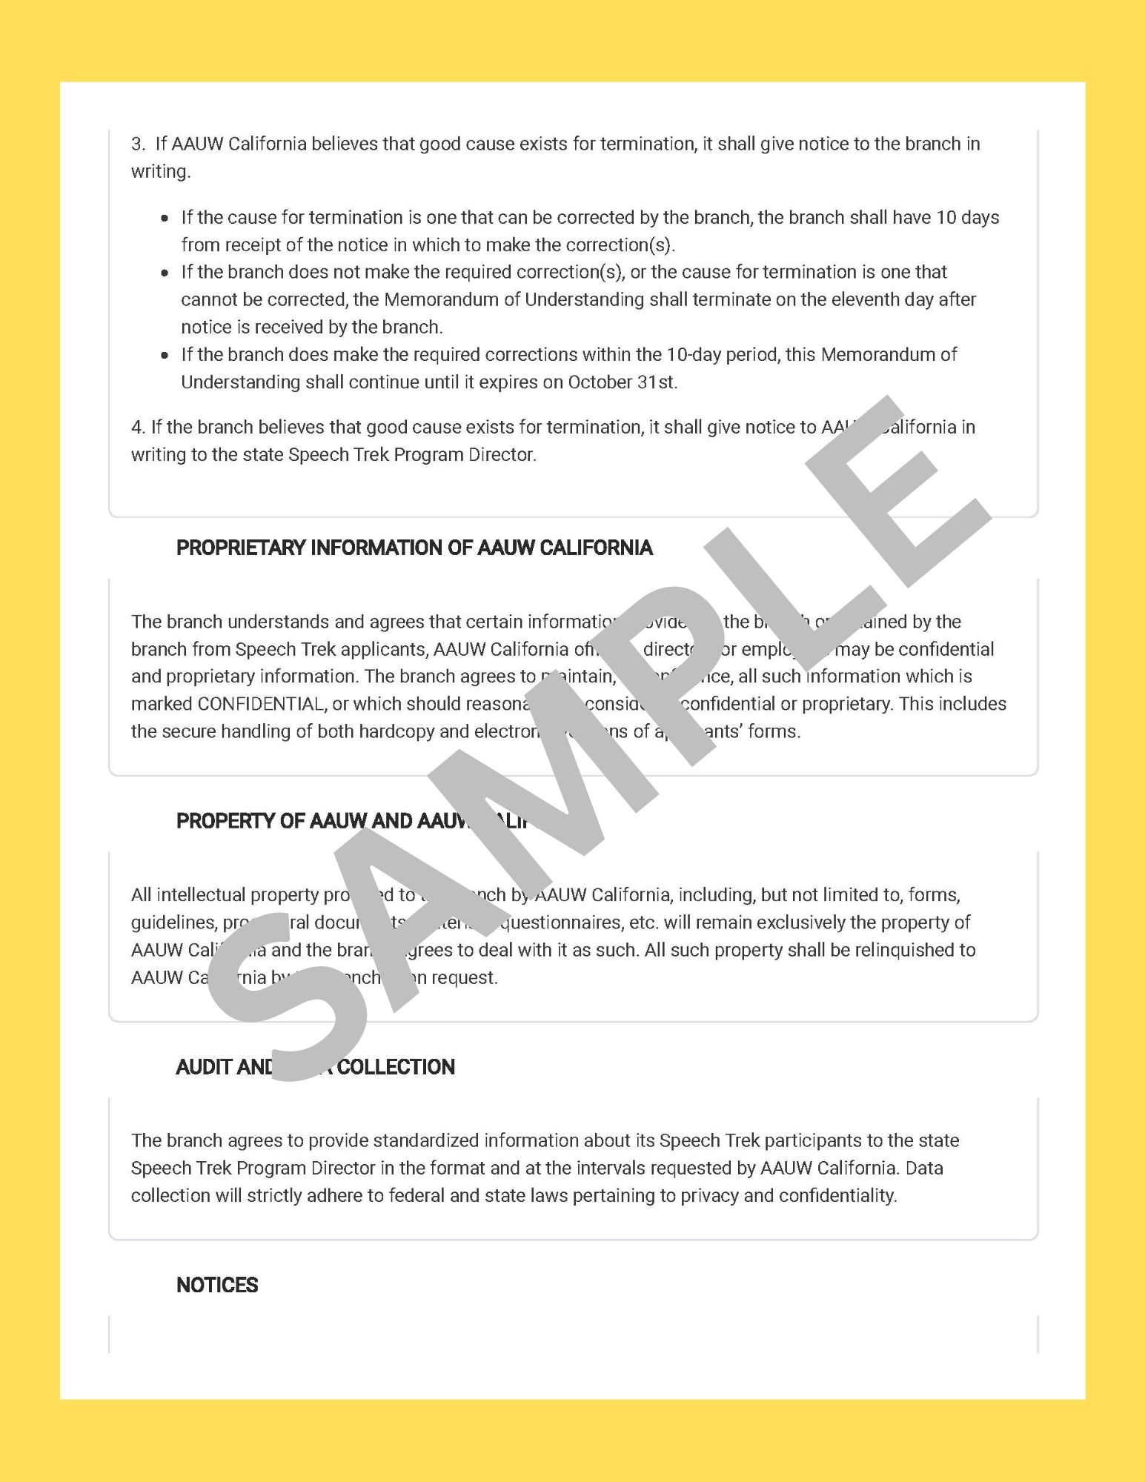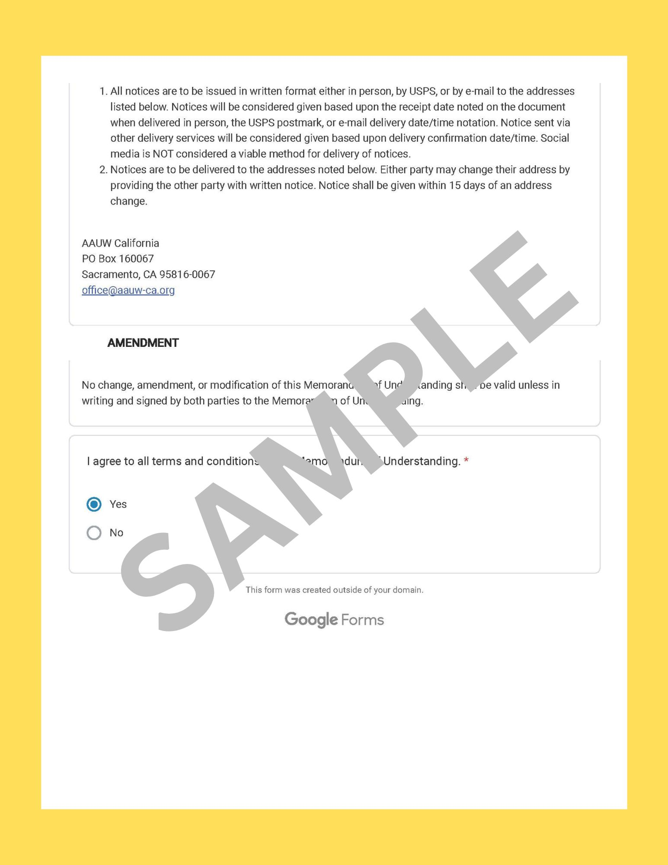

STUDENT APPLICATION AND PARENT/GUARDIAN PERMISSION
Student Name:
Email: | Phone:
Address:
High School Attending:
School Advisor/Counselor:
My signature below certifies that I wish to participate in the AAUW California Speech Contest and that I have received and read the following forms:
∎ Student Instructions ∎ Judge’s Instructions & Ballot
Student Signature: | Date:
Parent/Guardian Information and Permission:
Name:
Address:
Email: | Phone:
My signature below certifies that I have read the rules for the speech contest and wish for my child to participate in the AAUW California Speech Trek Contest. In addition, I understand that my child's name may be publicized locally as a contest participant, and that the speech will be recorded for higher-level competition and selection of finalists.
If my child is selected as the 1st place branch winner or one of three state finalists, I understand that the video of my child's competition speech may be posted online (see videos of previous speakers at: aauw-ca.org>Programs>Speech Trek) or used to promote the contest in subsequent years. I understand I will need to sign an AFFIDAVIT OF ELIGIBILITY AND LIABILITY RELEASE, prior to my child’s participation in the competition.
Parent/Guardian Signature: __________________________________________________ Date: ______________
Please return this application to your local branch contact: ____________________________________________________________________________________
Email: _______________________________________ Phone: _________________________________

BRANCH NOTICE OF CONTEST SEMI-FINALIST 2023-2024
Please send this form with the link (URL address) of your winning speaker’s YouTube video labeled “Speech Trek 2023-2024 – 1st Place - [full branch name and contestant name] to the address at the bottom of this page by March 15, 2024. This will enable us to have your entire information and student ID on one sheet of paper. Thank You!
Student Speaker Name:
Address:
Phone: | Email:
Parent/Guardian Name:
Address:
Email:
Your branch:
Branch president:
Email address:
Branch Speech Trek Chair/s:
Address:
Phone:
Email address:
URL address and link of branch winner’s video (example: https://youtu.be/aXnKCogdw_4):
_____Yes, the $25 branch fee is included. (Please make sure the entry fee of $25 is made out to “AAUW CA SPF” with “Speech Trek” and the branch name in the memo line of the check).
Mail to: Lana Widman, AAUW California Speech Trek Program Director
15 Shearwater Court, Sacramento, CA 95833

BRANCH-LEVEL SPEECH TREK SPEECH CONTEST

Speech Trek is a speaking contest open to all California high school students, whether from public, private, home, or continuation high schools. Students who were among the top three finalists in the state contest may not compete in any future state Speech Trek contests.
- The contest begins when your branch of AAUW California decides that they want to participate in the contest. Your board will meet and then determine the level of financial support necessary from your branch. Budget items may include prizes, printing, postage, video preparation, refreshments, or space rental for the contest. Branches vary in levels of prizes awarded to contestants--from certificates to actual cash awards. Your local branch covers all costs. Be sure to budget for the AAUW California Speech Trek Contest entry fee of $25.
- Next, identify a member to coordinate your contest and form a committee of interested members. Draw from members with interest or expertise with public speaking, writing press releases, connecting with high schools, recruiting, training, tutoring or coaching students, conducting fundraising; or just with an interest in raising awareness about the contest.
- Develop a calendar for the contest. Take time to check against competing events, such as the Lions Club Speech Contest, Rotary Speech Contest, Mock Trial, F.F.A. and other area speech contests, etc. Your calendar should include dates for:
    - Notice to state Speech Trek Program Director of branch’s MOU. (Deadline is November 18, 2023.)
    - Date of branch competition
    - Date for submitting branch winner's online submission to the state semifinals. (Deadline is March 15, 2024.)
    - Date of state competition if named to top three in the state. NOTE: State finals’ top three videos will be showcased at the AAUW California Annual Event on Saturday, April 27, 2024. This event will be virtual. Winners will be announced at this meeting.
- Create a list of your area high schools. Decide whether your contest will be limited to students within your city or county, and if it will be in-person or virtual. Create posters and recruitment brochures. Develop an email list for specific contact people to save costs of postage and printing.
- Arrange for informational meetings at your schools. Be willing to speak to student groups or classes. Your school may have a debate club or forensics program--or a Future Business Leaders chapter--or even a Mock Trial group just waiting for an opportunity to speak!
- Have the student and parent sign the participation agreement. This will protect your branch and allow it to publicize, photograph, and post the names of the participants.
- Write press releases to announce the contest.
- Notify AAUW California via the completed MOU that your branch intends to participate in Speech Trek by November 18, 2023. The online MOU asks for the branch name and mailing address as well as the president’s name and email address.
- Offer tutoring services to contestants. Tutors with experience may be available from local community college communication instructors or from local Toastmasters clubs. Working with the students helps to keep them on task with the topic and deadlines. You may decide to have a "rehearsal" prior to your contest or if participation is great, you may need to hold a semi-final round prior to your branch final contest.
- Hold your branch Speech Trek contest; video all speeches so that the winning speech can be posted to the AAUW California YouTube channel for submission to be considered at the state competition. NOTE: Only date-stamped videos taken AT the branch competition may be considered for the state competition; any taken after that date are automatically disqualified for consideration in the state competition.
- Prepare press releases of your branch winner for submission to local media.
- Submit a BRANCH NOTICE OF CONTEST SEMI-FINALIST 2023-2024 form, which includes the YouTube URL and link, and $25 fee made out to AAUW CA SPF (Special Projects Fund) with “Speech Trek” and <branch name> on the note line to Lana Widman, AAUW California Speech Trek Program Director, 15 Shearwater Court, Sacramento, CA, 95833, for the state semi-final round on or before March 15, 2024.
- Plan on attending the virtual AAUW California Annual Event to hear the top three speakers via video and see who will win the $1500 first prize. (If held in person, transportation, lodging, and meals for the finalists and one chaperone each are paid by Speech Trek.)
- Keep records for next year's contest. Share your success with our state Speech Trek Program Director at speechtrek@aauw-ca.org or call Lana Widman at (916) 207-5160.
The state Speech Trek Program Director is available to work with you to assure success with your competition. Have fun with this contest. This is an opportunity to increase awareness of AAUW in your community while having direct contact with high school students, their parents, and area educators.

SPEECH TREK 2023-2024 SCHEDULE
Branch Responsibilities: August 2023 - March 15, 2024
- Notify Speech Trek of your branch's intent to participate by submitting the MOU.
- Contact schools regarding participation.
- Identify and schedule judges for competition.
- Set a calendar for deadlines.
- Identify date, time, and location of contest.
- Hold branch speech contest, video the contestants, select winners.
- Send online submission (YouTube video link), $25 and BRANCH NOTICE OF CONTEST SEMI-FINALIST 2023-2024 to Lana Widman, Speech Trek Program Director, 15 Shearwater Court, Sacramento, CA 95833, no later than March 15, 2024
- For your own peace of mind, we recommend you also send an email notice to the state Speech Trek Program Director at speechtrek@aauw-ca.org so we can manage the online submission on the AAUW California YouTube channel and notify you when it has arrived.

State Responsibilities: March 15, 2024 - April 27, 2024
- The state Speech Trek Program Director receives BRANCH NOTICE OF CONTEST SEMI-FINALIST 2023-2024, which includes the YouTube URL of the branch winner, and the $25 entry fee.
- A judging panel of five will convene to select three finalists and two candidates for Honorable Mentions. The videos of the three finalists will be judged at the Annual Event. The Speech Trek Program Director will notify all participating branches of the winning finalists.
- The branch will have the pleasure of informing finalists of their win. The three finalists’ videos will be showcased at the virtual AAUW California Annual Event on Saturday, April 27, 2024.
- Speech Trek Program Director will introduce the three finalists’ videos and announce results.

SPEECH TREK PROCESS

- Get branch board approval and identify level of financial support.

- Select committee members.

- Develop a calendar for the competition and recruit judges for your competition.

- Create contact list of area high schools. Print posters and recruitment brochures.

- Arrange for informational meetings at schools.

- Make press releases to announce the contest.

- Offer tutoring service to contestants.

- Hold your branch SPEECH TREK Contest, videoing all speeches so that the winning speech can be posted to the AAUW California YouTube channel for submission for the state competition. NOTE: The contestant’s link to the video from the branch competition will be uploaded to the AAUW California YouTube channel. Only the unedited video taken at the branch competition in front of a live audience may be used for entry into the state competition, not one made at a later date. A submission using a video taken after the branch competition is automatically disqualified from the state competition. The video shall include only the contestant’s speech, and the YouTube time stamp shall be used by the judges to confirm that the speech meets the time requirements.

- PLEASE NOTE: In the event that an in-person performance is not possible, the branch may conduct the contest via a video conferencing tool such as Zoom. All other competition rules remain in place. For technical assistance, please contact webteam@aauw-ca.org.
- Distribute press releases about branch contest winners.

- Submit all required forms and fees to the state Speech Trek Program Director for branch competition winner to be considered in the state competition.

SAMPLE LETTER TO SCHOOL ADMINISTRATOR

(Date)

Dear School Administrator:
The [BRANCH NAME] of the American Association of University Women is participating in the annual AAUW California Speech Trek competition and is inviting all interested high school students to participate in our local competition. This year, the contest will be held {in person} {virtually]. We hope to encourage a wide variety of students to take part in this competitive speaking opportunity and would like to direct information to your staff for dissemination to students.
Attached is the information and requirements regarding the local competition. We seek your approval to send this information to your school’s English/Speech/Drama/Business/ Mock Trial teachers and counselors. Contact us through the numbers listed below so that we may send information to your staff - or to arrange for an informational meeting at your school.
We hope that you will view this competition as empowering for all students and that it receives your endorsement. Thank you for providing support for this activity.
Regards,

Name
Speech Trek Chair
email:
phone:
website:

SAMPLE LETTER TO TEACHER
(Date)
Mrs. Judy Novo
Watsonville High School
123 Beach Street
Watsonville, CA 95076

Dear Judy,
The Watsonville Branch of the American Association of University Women is pleased to announce a statewide speech contest--SPEECH TREK--for high school students.
During the coming week I will call to request a time to meet you and discuss this exciting opportunity. In addition to contest incentives at the local level, three talented students will be invited to showcase their winning videos at the virtual AAUW California Annual Event where they will compete for cash prizes.
I have enclosed information on the topic and a poster announcing the contest.
The 2023-2024 topic:
How can we ensure a robust public-school curriculum that is accessible to all and teaches historically accurate information?

Thank you for your time. I look forward to speaking with you in the coming week.
Sincerely,
Speech Trek Chair

STUDENT INSTRUCTIONS
Note: These instructions have been simplified in the Student Toolkit
Eligibility: Speech Trek is open to all students actively enrolled in high school in California. Students who were among the top three finalists at a previous state Speech Trek competition may NOT compete again at the state level. This contest is open to girls and boys enrolled in public and private high schools, as well as home-schooled students and those enrolled through continuation high schools.
Deadlines: Interested students must submit a "Student Application and Parent/Guardian Permission" notice and a participation agreement (AFFIDAVIT OF ELIGIBILITY AND LIABILITY RELEASE), to their local AAUW California branch no later than ___________________ (to be determined by each branch).
Time Limits: Students are to prepare an original 5-6-minute speech with a 30-second grace period on either side. Timing will begin when the contestant first speaks. Failure to meet the 5-6 minute and grace period time limit will result in disqualification.
Prizes: Each local branch of AAUW California will determine the level of award for their contestants. Branches typically offer a Certificate of Participation. Additional cash prizes are at branch discretion.
First Place Winners: Each branch will upload the video of their first place speech to YouTube. AAUW California will then upload the video to the AAUW California YouTube channel. The video must be submitted to the state level contest by March 15th for the state competition. From the videos entered into the state competition, two contestants will be named as honorable mentions and receive $250 as the 4th place winner and $150 as the 5th place winner. This year, the top three finalists’ videos will be showcased at the AAUW California Annual Event on April 27, 2024. Please note that this meeting will be held virtually, and the Speech Trek Program Director will introduce each video and announce the winners.
The first-place winner at the state contest will receive $1500, second place winner at the state contest will receive $1000, and third place winner at the state contest will receive $500.
Each speaker shall:
- Read the student instructions thoroughly at or before the first meeting with the speech contest coach, if available.
- Complete and sign a Student Application/Parent Permission Form.
- Using the topic and background as a guide, prepare a draft of an original speech, between five and six minutes in length, allowing for a 30-second grace period on either side.
- Meet with the contest coach, if available, to review, revise, and practice the speech.
- Arrive 20 minutes prior to the contest to become familiar with the setting.
- Draw a number to determine the order of speakers.
- Give her/his speech.
- Give a one-two minute biography as an introduction (after all speeches have been given).

The local branch will notify the speaker of the results and upload the video of the first-place winner to YouTube.

The state Speech Trek Program Director will confirm uploaded videos of branch winning speeches and convene five statewide judges to select the top five speeches, and then notify speakers of their standing at the state level by April 8.

After showcasing the top three speeches at the virtual AAUW California Annual Event, the first-place winner will receive $1500 and a Certificate of Participation. The second-place winner will receive $1000 and a Certificate of Participation. The third-place winner will receive $500 and a Certificate of Participation. The 4th & 5th place finalists will be awarded $250/$150 respectively along with a Certificate of Participation.

Your school contact is: ______________________________________________________________________________
Phone: ______________________________________ Email_______________________________________________
Your AAUW branch contact is:____________________ __________________________________________________
Phone: ______________________________________Email________________________________________________
Your speech contest coach, if available,, is: ____________________________________________________________________ Phone: ______________________________________Email_______________________________________________

INSTRUCTIONS FOR GREETER
(note: adapt instructions for virtual contest)

Thank you for agreeing to serve as a Greeter for the AAUW Speech Trek contest. This contest is an opportunity to support talented young men and women who are America's future leaders.
- Prepare a sign-in table with a program, branch and/or membership information, and name tags if desired. Be sure sign-in materials include name, address, phone, and email.

- Choose someone to monitor this process who understands this information will be necessary for follow-up membership activity.

- Greet students, parents, judges, advisors, and honored guests and show them where to sign in.

- Prepare separate lists of names of parents, judges, advisors, and honored guests for use during introductions.

- Make slips of paper with one number on each (1, 2, 3, etc.) for the number of speakers you expect and then put the slips into a container. Each contestant is to draw a number to determine the speaking order.

- While scores are being tabulated, the emcee may allow each contestant to give a brief biography or may engage in a brief discussion with the contestant. As time permits, contestants may comment on or acknowledge their parents or teachers.

- At the end of the contest, if the meeting will continue, a break is needed to allow everyone to congratulate the speakers.

- Be sure someone/emcee invites all guests to complete the membership inquiry/application form to be invited to a follow-up event to learn more about the branch.

INSTRUCTIONS FOR TIMER
Thank you for agreeing to serve as a timer for the AAUW California Speech Trek contest. This contest is an opportunity to support talented young students, both girls and boys, who are America's future leaders.
A timer will need:
- A stopwatch or equivalent timing device.

- Three (3) timecards that indicate time intervals of 4:30, 5:30, and 6:00 minutes. These timecards can be color-coded (for example, green at 4:30; yellow at 5:30; and red at 6:00 minutes).
Instructions:
- Please seat yourself directly in front of where the contestants will speak.

- Begin timing when the contestant first starts to speak.

- At 4:30, raise and hold the green card.

- At 5:30, raise and hold the yellow card.

- At 6:00, raise and hold the red card. Hold it until the speaker stops speaking. A 30-second grace period exists before and after the allotted time. A speaker who speaks under 4:30 or over 6:30 will automatically be disqualified.

- Time stops when the speaker stops speaking. After each speaker is finished, write down the total time spoken and hand it to the coordinator.

- Clear stopwatch/timing device after each speaker.

NOTE: if a contestant is under or over the time limit, the contest emcee announces simply that a contestant has been disqualified for time; no name is mentioned.

INSTRUCTIONS TO JUDGES
- Each speaker shall prepare and deliver an original five-six (5:00-6:00) minute speech with a 30-second grace period on either side.
- Time signals will be given for each speaker; however, adherence to the time limit is the responsibility of the speaker.
- This speech is to be presented by using the extemporaneous mode of delivery. Appropriate use of ONE 4" x 6" note card is an option--prompting is not allowed.
- In this contest, students have written their own speeches. They are permitted to deviate from their original manuscript to better adjust to the speaking situation.
- Speakers will typically use logical and emotional appeals.
- Some speakers will employ language that is graphic, striking, and sometimes dramatic--but always with the intent of conveying the speaker's ideas, rather than the speaker's technique. These presentations are to be original speeches and not dramatic readings.
- During the state semifinal (via YouTube) and final competition (also via YouTube if the contest if held virtually), semi-final judges and finals judges shall use the official ballot and score each speaker in two key areas: Content, 0-50 points (includes introduction, organization, and conclusion); and Delivery, 0-50 points. Assign a score for each category by entering the number in the appropriate square on your ballot.
- After scoring each category, subtotal the score for each speaker and then rank the speakers from the highest to the lowest.
- In the event of a tie at the semi-finals and final competitions, an additional ballot will be opened to break the tie. This additional judge, known as a “tie-breaking” judge, judges and ranks all contestants. The ballot is unsealed only in the case of a tie. If there is no tie, then the tie-breaking judge’s ballot remains sealed.
- Judges must make independent decisions about the speakers. Judges shall not discuss decisions with other judges prior to submitting final ballots.
The official timekeeper may share only that a speaker was outside the time range. Speaking over 6 minutes and 30 seconds or under 4 minutes and 30 seconds will result in disqualification.
If a judge submits a ballot without ranking the speakers, the form will be returned for completion of the rankings. Questions regarding contest rules or conduct of the event shall be referred to the contest coordinator.
(Branches may opt to use their own Judge’s ballot at the local level, but students moving on to the state semi-final or final round must be given a copy of the official ballot used for state level competition.)

2023-2024 - JUDGES BALLOT
Topic: How can we ensure a robust public-school curriculum that is accessible to all and teaches historically accurate information?
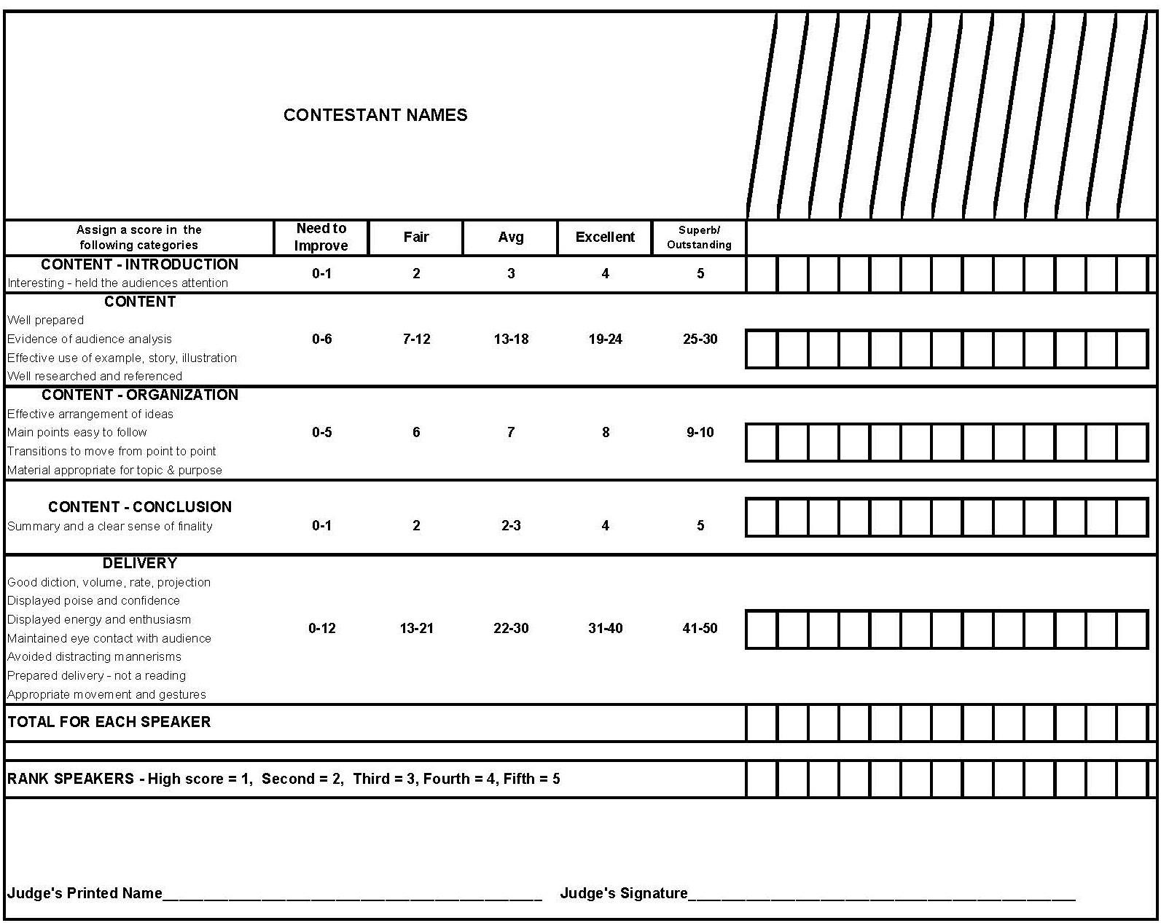

SAMPLE NEWS RELEASE - BEFORE THE EVENT

News Release: IMMEDIATE
Contact:
Phone Number:
Email address:

AAUW SPEECH CONTEST FOR HIGH SCHOOL STUDENTS
Dateline: Pismo Beach, CA, September 10, 2023. The American Association of
University Women, Pismo Beach Branch, will welcome three Pioneer High School students to participate in a speech contest on Sunday, September 21, at 2:00 P.M.
in the High School Auditorium, corner of Moffitt and J Street. The contestants,
Anna Campos, Justine Jordan, and Jyun Yi Kang, will speak for five to six minutes on the
topic: “How can we ensure a robust public-school curriculum that is accessible to all and teaches historically accurate information?”
City and communications leaders will serve as judges. Branch President
Karen Jacks will emcee. The public is welcome. Refreshments will be served, and
tickets can be purchased at the door for $5.
The local first-place winner will receive $150 and will automatically advance to
the state semi-final competition where three finalists from throughout the state
will be chosen to compete at the AAUW California Annual Event with the opportunity to win cash awards of $1500, $1000, and $500
Contact Janet Swift, event coordinator at (831) 345 2664 for more information.

SAMPLE NEWS RELEASE - AFTER THE EVENT

News Release: IMMEDIATE
Contact: Lana Widman
AAUW California Speech Trek Program Director
Phone Number: 916-207-5160
Email Address: speechtrek@aauw-ca.org

<Contestant>, a senior at <school name> High School in <city>, took first place in the April 27th AAUW California Speech Trek Speech Contest at the year-end Annual Event of the American Association of University Women California (AAUW California). <Contestant> was one of the three finalists to compete. <2nd contestant>, a junior at <school name> in <city>, took second place, while <3rd contestant>, a senior at <school and city>, took third.
High school students from throughout California are invited to compete annually. The topic, “How can we ensure a robust public-school curriculum that is accessible to all and teaches historically accurate information?” inspired lively speeches. The statewide contest begins at the AAUW branch level. Videos of the first-place branch winners are then reviewed to determine the three finalists’ videos to showcase at the AAUW California Annual Event. All three finalists received cash awards of $1500, $1000, and $500 respectively. To view the winning speech, go to www.aauw-ca.org > Programs/Projects>Speech Trek.
You will also find a Student Toolkit about next year’s contest on the AAUW California website. Requests for additional information may be sent to: Lana Widman, AAUW California Speech Trek Program Director at speechtrek@aauw-ca.org.

AFFIDAVIT OF ELIGIBILITY AND LIABILITY RELEASE
AAUW Speech Trek Contest
The undersigned participant of the American Association of University Women (AAUW) Speech Trek Contest and the participant’s parent or guardian hereby declare that they have read and understand all of the rules and conditions for the contest and that the undersigned has met all eligibility requirements on the date their contest entry was submitted.
The undersigned and the participant’s parent or guardian represent that the speech submitted to the contest (the “Entry”) is the participant’s own original creation, and that the participant has perpetrated no fraud or deception in entering the contest or claiming any prize.
The undersigned and the participant’s parent or guardian represent and warrant that neither she/he nor any parent or guardian is an employee of AAUW, or its related, parent, affiliated and subsidiary companies, advertising and promotion agencies, or the panel of judges, nor is she/he or any parent or guardian connected with them in any way.
The undersigned and the participant’s parent or guardian irrevocably grant to AAUW, its successors and assigns and all other persons deriving rights from them, all rights, title and interest in the undersigned's Entry in perpetuity, to print, publish, broadcast, use or modify in any manner in any media whatsoever the Entry as submitted for the contest to the fullest extent permitted by applicable law.
In addition, the undersigned and the participant’s parent or guardian grant to AAUW, its successors and assigns and all other persons deriving rights from them, the right to use the participant’s name, likeness and/or voice and biographical information, and city of residence for promotional purposes in any medium without compensation, to the fullest extent permitted by applicable law.
The undersigned and the participant’s parent or guardian hereby waive the opportunity and any right to inspect or approve any such promotion, printing, broadcast use or publication, and further release AAUW, its successors and assigns from all liability in connection with any such promotion, printing, broadcast, use or publication.
The undersigned and the participant’s parent or guardian hereby release and hold harmless AAUW and its officers, directors, employees, and agents from any and all losses, claims or damages that may result, directly or indirectly, from participation in the contest or use of the prize award. The undersigned understands that any and all local, state or federal tax liability for the award will be the responsibility of the undersigned and the participant’s parent or guardian.
The undersigned and the participant’s parent or guardian further acknowledge and agree that the contest prize is non-transferable, and that no substitution of prizes will be allowed, except by the AAUW due to the unavailability of prizes at the time of the award.

The undersigned and the participant’s parent or guardian understand that AAUW is proceeding with the award of any prize in the contest in express reliance on this release and the undersigned and the participant’s parent or guardian represent and agree that they are free to grant the rights set forth in this release.
The undersigned contest participant and the participant’s parent or guardian hereby attest that they have read and understand all the foregoing provisions of this affidavit and agree to be bound by the same.

Signature of contest participant Date

Name ________________________________________________________________________
Address_______________________________________________________________________
______________________________________________________________________________
Email address___________________________________________________________________
Phone number__________________________________________________________________

__________________________________________________
Signature of parent/guardian (if contest participant is under 18 years of age)

Print name of parent or guardian

Dated:_____________________________________________

